Year Six Curriculum Map 2025-26

 | Autumn 1 | Autumn 2 | Spring 1 | Spring 2 | Summer 1 | Summer 2
Vehicle Text: | Rose Blanche  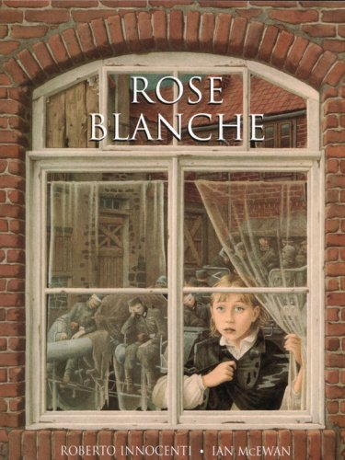 | 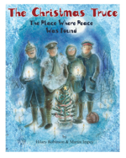  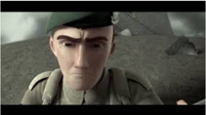  Beyond the Lines/ The Christmas Truce | 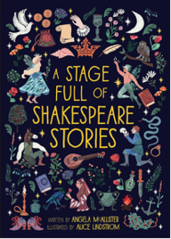  Macbeth | 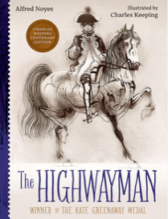  The Highwayman | 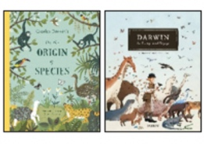  Origin of the Species | Varmints  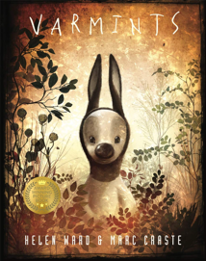
English:  Writing Outcome  & Purposes | Recount– Diary  Recount – Bravery Speech Award | Narrative – Flashback Narrative  Recount – Letter | Narrative – Tragedy narrative  Persuasive Letter | Narrative- Suspense Narrative  Recount – Eyewitness account/ Newspaper | Narrative – Discovery Narrative  Explanation text – Animal  Adaptation | Narrative – Environmental Change narrative
Whole Class Reading | 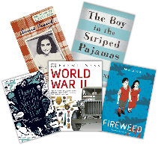  History: War | 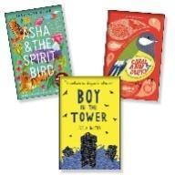  Reading Breadth: Modern Fiction & Poetry | 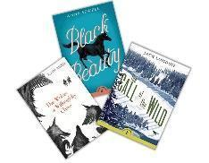  Reading Breadth: Literary Heritage & Plays & Poetry | Reading comprehension skills lessons using a wide variety of text extracts | 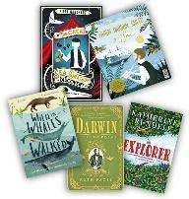  Science: Evolution and Inheritance | 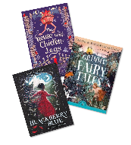  Reading Breadth: Traditional Tales and Poetry
Mathematics | Number: Place Value  Number: Addition, Subtraction, Multiplication and Division | Number: Fractions  Units A & B  Measurement: Converting Units | Number: Ratio  Number: Algebra  Number: Decimals | Number: Fractions, Decimals and Percentages  Measurement: Area, Perimeter and Volume  Statistics | Geometry: Shape  Geometry: Position and Direction | Themed projects, consolidation and problem solving
Science | Light | Electricity | Living Things and Their Habitats | Animals including Humans. | Evolution and Inheritance | Looking after our Environment
PSHE - Jigsaw | Being Me in My World | Celebrating Difference | Dreams and Goals | Healthy Me | Relationships | Changing Me
R.E.  Key Question:  Is life like a journey? | Christianity (God) How do Christians mark the turning point of life? | Hindu Dharma Is there one journey or many? | Buddhism What do we mean by a good life? | Christianity (Jesus) - Why do Christians believe that ‘Good Friday’ is good? | Islam What is Hajj and why is it important to Muslims? | Christianity (Church) How do Christians mark the turning point of life?
History | What impact has war and conflict had on our local area (Warrington)? |  | Crime and Punishment from the Anglo-Saxons to present day  A study of an aspect or theme in British history that extends pupils’ chronological knowledge beyond 1066.  Securing and deepening knowledge of British history
Geography | Maps, atlases, globes, digital mapping, 8 points of a compass, 4 & 6 figure grid references and field work to be covered throughout the year.
 | Field Study and Mapping Skills Conflict and Memorials in Warrington linked to History work |  |  |  | South America  Vegetation Belts, Climate Zones and Biomes  Revisit and deepen: map skills  Revisit and deepen: All living things - classify South American living things/ Charles Darwin
Art & Design | Drawing: Expressing Ideas |  | Craft and Design: Photo Opportunity |  | Sculpture and 3D: Making Memories
Design & Technology |  | Structures: Anderson Shelters |  | Textiles: Waistcoats – linked to Macbeth |  | Digital World: Navigating the World
Spanish | Phonetics 1-4 | At the Weekend | Planets | Healthy Lifestyle | Vikings | Me in the World
 | At School
Computing – iLearn2 | Digital Literacy: Online Safety  Computer Science: Programming in Scratch |  | Information Technology: Photograph and image editing and Graphic Design |  | Information Technology  Data Detectives and Web Design
P.E. | Gymnastics  Invasion games -  Football | Dance  Invasion Games-  Basketball | Striking and  Fielding Cricket-  Cheshire Cricket*  Fitness | Net and Wall Games- Volleyball  Yoga | OAA  Capoeira | Athletics  Striking and Fielding Games- Rounders
Music | Songs of  World War 2 | Theme and Variation | Baroque |  | Composing and performing a Leavers’ Song

