


PUPIL ABSENCE REQUEST

It is a legal requirement for parents/carers to obtain the permission of the Headteacher before removing their child from school in order to take any leave in term time. Parents do not have an automatic right to take their children out of school for leave during term time without prior arrangement with the Headteacher. The legislation only allows the Headteacher to authorise such leave in exceptional circumstances. To apply for a child to be granted leave from school parents should complete this form and return it to school for consideration well in advance of the proposed leave and before committing to any expense. Upon receipt of a request, the Headteacher will make a decision as to whether to authorise the absence, being mindful of government regulations and LA guidance.
Where school have concerns about the leave request, the Headteacher or their representative may arrange to meet with you to discuss your application.
PARENTS’ SECTION (NB: the application must come from the parent with whom the child normally resides)
Please attach additional sheets if necessary
Surname of child: |  | First name of child:
Date of Birth: |  | Year Group:
Parent/Carer surname: |  | Parent/Carer first name:
Home address:
Postcode: |  | Telephone number:
Postcode: |  | Email address:
Please provide information regarding the exceptional circumstances supporting this application for leave
Length of absence (number of school days) |  | Destination (if applicable)
Date of departure |  | Date due back in school
Emergency UK telephone contact name and number
Employer Details  If you are stating work commitments as an exceptional reason for requesting leave, please complete this section and attach any evidence you have showing why leave cannot be taken during the school holidays | Name:
 | Address:
 | Telephone:

Parent/Carer signature
Date of Application

ADDITIONAL FACTORS FOR CONSIDERATION
Pupils attend school for a maximum of 190 days each academic year. Regular attendance is vital for your child's educational progress. The Local Authority expects that all parents/carers ensure their children attend school whenever possible. Absence during school time is largely prohibited by regulation and hinders academic progress. Even in exceptional circumstances, the following factors may be taken into account when considering an application for leave:
- Will leave, at this point in time, be detrimental to the pupil’s education?
- Will they miss any national tests or examinations?
- Is their attendance a cause for concern?
- Have they already had leave during term time this year?
- Did they have leave of absence during term time in the previous school year(s)?
- Do they have any absences which have been recorded as unauthorised this year?

Where a child has 10 or more unauthorised absences (equivalent to 5 full school days) in an academic year, this may result in a Fixed Penalty Notice (FPN) being issued.

Fixed Penalty Notice Charges

- £80 per parent, per child if paid within 21 days.
- £160 per parent per child if paid within 28 days.
- Failure to pay may lead to prosecution in Magistrates Court.

A maximum of two Fixed Penalty Notices can be issued per parent for the same child within a three-year period. After this, any further unauthorised absence may result in a prosecution.

SCHOOL SECTION:

Leave request approved? | YES | No
Reason(s) for decision

Headteacher's signature
Date
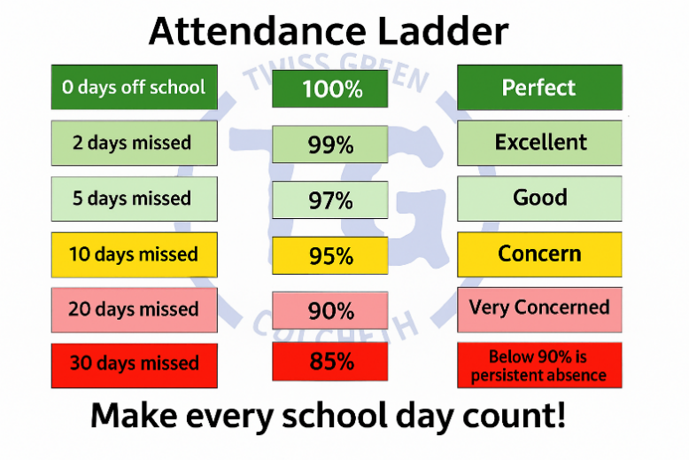
Date parent informed of decision: ………………………. Added to SIMS……………….
Your child’s attendance is:
%

