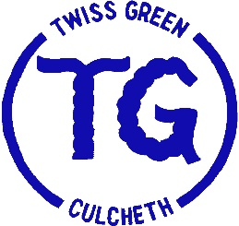
2019 End of Year Results

Please see table below to compare school results with national average scores (these are in brackets).

KS2 2019 | % working at/above the expected level | % achieving the ‘higher standard
Reading, Writing and Mathematics combined | 97 (65) | 24 (11)
Reading | 100 (73) | 52 (27)
Writing | 97 (79) | 41 (20)
Maths | 100 (79) | 35 (27)

KS2 Average scaled scores 2019

Reading | 109 | (104)
Mathematics | 108 | (105)
Grammar, Punctuation and Spelling | 112 | (106)

End of Key Stage 2 average 2017/2018/2019

 | % working at/above the expected level | % achieving the ‘higher standard
Reading, Writing and Mathematics combined at Twiss Green | 91 | 23
Reading, Writing and Mathematics combined national outcomes | (63) | (10)

End of KS1 2019 | % working at/above the expected level | % achieving the ‘higher standard
Reading, Writing and Mathematics combined | 82 (55) | 32 (11)
Reading | 89 (75) | 43 (25)
Writing | 89 (69) | 50 (14)
Maths | 93 (76) | 46 (22)

Phonics Screen 2019

Year 1 | 87 | (82)

EYFS: Good Level of Development

Reception | 74 | (72)

