Prompt 2

What is happening this week? Can you describe it in your own words?

Where is it happening? Can you locate it on a map?

What do you think about this week’s story? How does it make you feel?

Have you ever experienced anything like this or
come across anything like this before? When was it?
Where was it?

I think
I feel
I prefer
I know
I believe
The best thing about
The worst thing about

How do you think the people involved in the story feel?

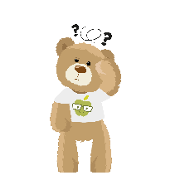
How does it make me feel?

sad | angry | happy | confused | excited | worried | shocked | afraid
despondent  disconsolate  dismal  doleful  downhearted  forlorn  gloomy  melancholic  miserable  woeful  wretched | aggrieved  annoyed  discontented  disgruntled  distressed  exasperated  frustrated  indignant  offended  outraged  resentful  vexed | beaming  buoyant  cheery  contented  delighted  enraptured  gleeful  glowing  joyful | addled  baffled  bemused  bewildered  disorientated  indistinct  muddled  mystified  perplexed  puzzled | animated  elevated  enlivened  enthusiastic  exhilarated  exuberant  thrilled | agitated  anxious  apprehensive  concerned  disquieted  distraught  distressed  disturbed  fretful  perturbed  troubled  uneasy | astonished  astounded  disconcerted  distressed  dumbfounded  horrified  staggered  startled  startled  stunned  surprised | alarmed  apprehensive  daunted  fearful  frantic  horrified  petrified  terrified

Can you describe how somebody with a different opinion to yours might feel?

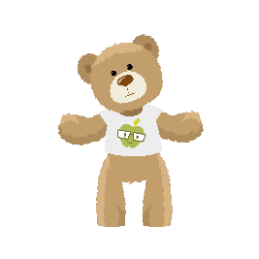
What have you learned from this week’s story?

Do you want to do anything about it? What could you do?
Make a plan!

Share your thoughts on our online discussion board: www.picture-news.co.uk/discuss

