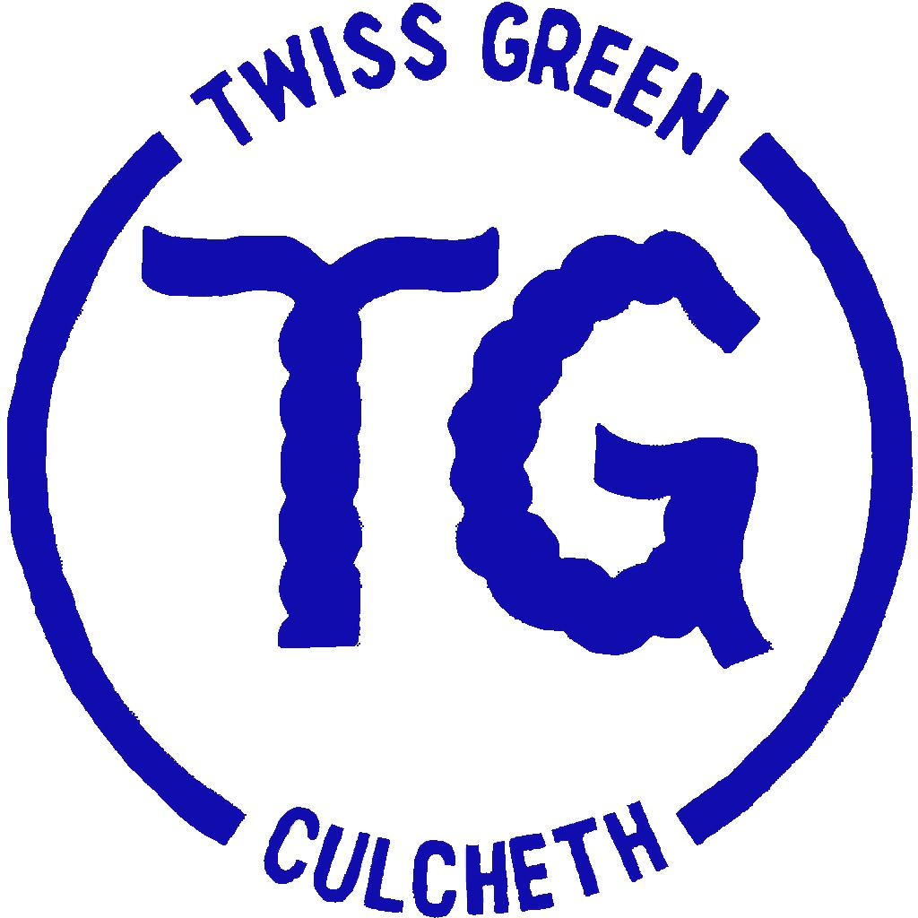
TWISS GREEN COMMUNITY PRIMARY SCHOOL POLICY STATEMENT

Physical Education Policy
Intent
To produce and deliver an all inclusive, child-centred subject to promote and develop physical literacy for all children, with the intention of all children becoming holistic learners. The subject will compliment behaviours and attitudes towards learning and encourage a positive relationship with health & fitness to produce informed, lifelong participants in physical activity and self wellbeing, regardless of physical ability. Physical education will develop the children’s knowledge, skills and understanding, so that they can perform with increasing competence and confidence in a range of physical activities. Physical education will promote an understanding in children of their bodies in action. It will involve thinking, selecting and applying skills and promote positive attitudes towards a healthy lifestyle.
The aims of PE are:
• to enable children to develop and explore physical skills with increasing control and co-ordination;
• to develop the way children perform skills and apply rules and conventions for different activities;
• to increase children’s ability to use what they have learnt to improve the quality and control of their performance;
• to teach children to recognise and describe how their bodies feel during exercise;
• to develop an understanding in children of how to succeed in a range of physical activities and how to evaluate their own success;
- to develop competence to excel in a broad range of physical activities;

- to be physically active for sustained periods of time;

- to engage in competitive sports and activities;

- to lead healthy and active lives.
Funding
Schools receive PE and sport premium funding based on the number of pupils in years 1 to 6. This funding must be used to make additional and sustainable improvements to the quality of PE and sport we offer.
We use the premium to:
- Develop or add to the PE and sport activities that we already offer;

- Build capacity and capability within the school to ensure that improvements made now will benefit pupils joining the school in future years.
There are 5 key indicators that we should expect to see improvement across:
- the engagement of all pupils in regular physical activity - the Chief Medical Officer guidelines recommend that all children and young people aged 5 to 18 engage in at least 60 minutes of physical activity a day, of which 30 minutes should be in school;
- The profile of PE and sport is raised across the school as a tool for whole-school improvement;
- Increased confidence, knowledge and skills of all staff in teaching PE and sport;
- Broader experience of a range of sports and activities offered to all pupils;
- Increased participation in competitive sport.
As part of the funding criteria we are required to publish details (on our website) of how we plan to spend the monies and a review of the impact on pupil outcomes.
Teaching and learning style
We use a variety of teaching and learning styles in PE lessons. Our principal aim is to develop the children’s knowledge, skills and understanding and we do this through a mixture of whole-class teaching and individual, paired and group activities.
Teachers draw attention to good examples of individual performance as models for the other children and we encourage the children to evaluate their own work, as well as the work of other children. Within lessons, we give the children the opportunity to use a wide range of resources.
Before any PE lesson, teachers should ensure that children change before an interactive timer has run out. Children should be rewarded with stickers or house points. When children are getting changed back into uniforms after PE lessons, teachers should encourage fast changing whilst thinking about an aspect of the lesson.
Curriculum
The areas of physical activity (games, gymnastics, dance, athletics, swimming and outdoor activities) are set out in the Foundation Stage Curriculum and National Curriculum 2014. At Twiss Green, we have adopted the REAL PE, REAL Gym and Creative Steps schemes of work for the teaching of skills in PE. Each year group will learn PE in accordance with the PE overview. This will ensure continuity and progression through school in order to continue to improve standards in PE.
PE KIT
Shorts, t shirt and bare feet must be worn for indoor dance and gym. Any feet infections, i.e. veruccas should be covered with a plaster. Depending on weather, tracksuits or shorts and t shirts with trainers can be worn outside.
Resources
All teachers have access to centrally stored PE resources. Resources are kept in two locations; indoor stores across both Key Stages. All PE resources are checked regularly to ensure that they meet health and safety requirements, and in addition to this, all resources are audited annually.
Personal, Social and Health Education (PSHE)
PE contributes to the teaching of personal, social and health emotional education. Children learn about the benefits of exercise and healthy eating, and how to make informed choices about these things.
The teaching of PE offers opportunities to support the social development of our children through the way we expect them to work with each other in lessons. Groupings allow children to work together and give them the chance to discuss their ideas and performance. Their work in general enables them to develop a respect for other children’s levels of ability, and encourages them to co-operate across a range of activities and experiences. Children learn to respect and work with each other, and develop a better understanding of themselves and of each other.
Information Technology and Computing (IT&C)
We use ICT to support PE teaching when appropriate. In dance and gymnastics children make video recordings on the iPads of their performance, and use them to develop their movements and actions. Older children compare each other’s performance from recordings and use these to improve the quality of their work.
Inclusion
In accordance with the school’s Inclusion Policy, PE activities are differentiated to meet the needs of each pupil. More Able and Talented pupils and children with Special Educational Needs and Disability will be identified through a range of activities. Their needs will be met through the development of individual or group programmes that encompass a range of learning styles and are designed to enrich the curriculum.
Equality
Teachers will ensure that all pupils have fair access to the PE curriculum, regardless of gender, race, or ability, in accordance with the school’s Equality Policy.
Assessment and recording
Teachers assess pupil progress in PE by making judgements as they observe them working during lessons. Check whole school approach to assessment.

Extra-curricular activities
The school provides a range of physical activities including netball, football, rugby (tag and contact) and running for children at the end of the school day. These encourage children to further develop their skills in a range of the activity areas. The school sends details of the physical activity clubs to parents at the beginning of each term. The school also takes part in regular competitive sports and activities against other local schools and participates in competitions. This introduces a competitive element to team games and allows the children to put into practice the skills that they have developed in their lessons. These opportunities foster a sense of team spirit and co-operation amongst our children.
Health and safety
The general teaching requirements for health and safety apply in this subject. We encourage the children to consider their own safety and the safety of others at all times.
We expect the children to change for PE into the agreed clothing for each physical activity area. The governing body expects the teachers to set a good example by wearing appropriate clothing when teaching PE. The policy is that no jewellery is to be worn for any physical activity and long hair should be tied back.
When using apparatus, this is to be used sensibly and safely. Children in upper Key Stage 2 can usually be used as monitors for setting and carrying equipment for lessons. In Key Stage 1 and lower Key Stage 2, the children must be supervised when moving and setting equipment, including mats and benches. The correct handling and lifting of equipment will be taught to children within lessons.

