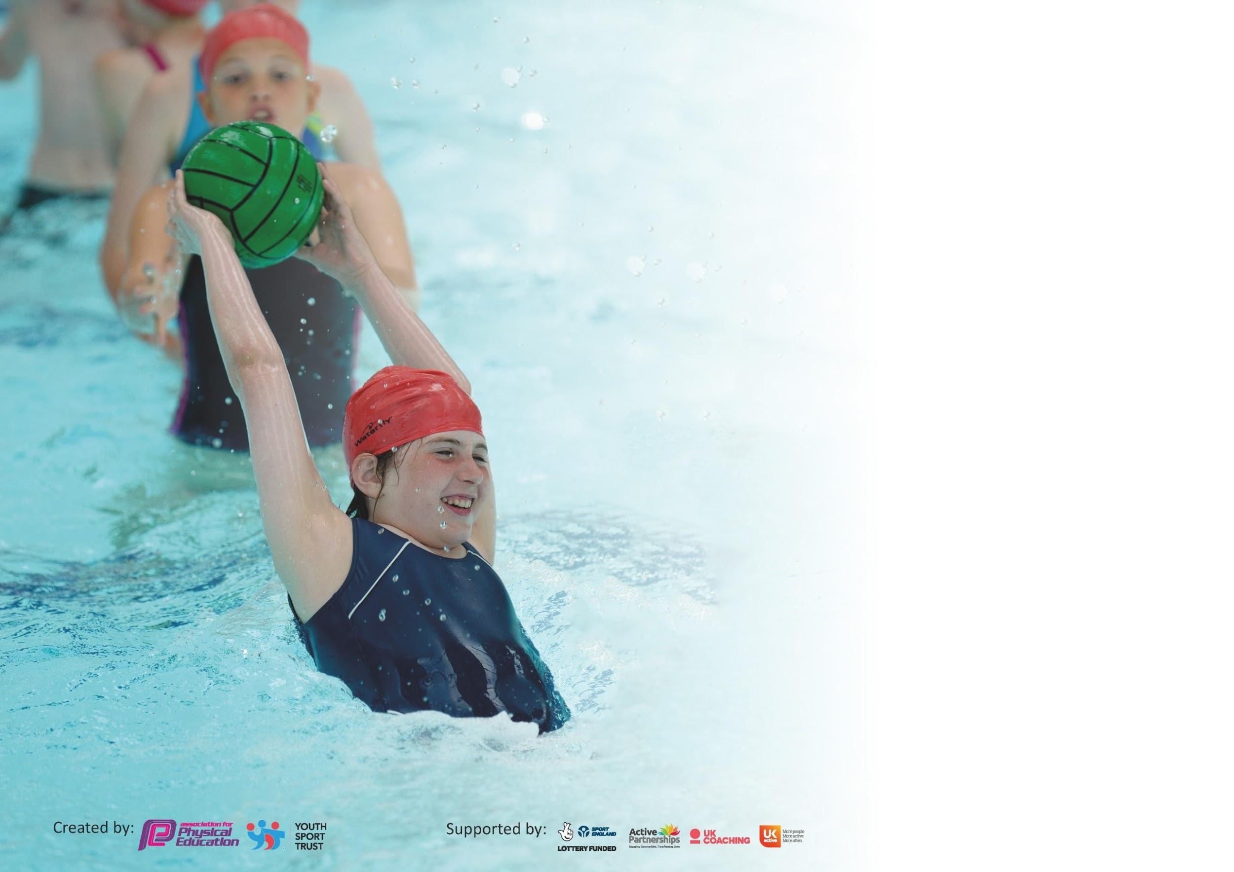

It is important that your grant is used effectively and based on school need. The Education Inspection Framework (Ofsted 2019 p64) makes clear there will be a focus on ‘whether leaders and those responsible for governors all understand their respective roles and perform these in a way that enhances the effectiveness of the school’.

Under the Quality of Education criteria (p41) inspectors consider the extent to which schools can articulate their curriculum (INTENT), construct their curriculum (IMPLEMENTATION) and demonstrate the outcomes which result (IMPACT).

To assist schools with common transferable language this template has been developed to utilise the same three headings which should make your plans easily transferable between working documents.

Schools must use the funding to make additional and sustainable improvements to the quality of Physical Education, School Sport and Physical Activity (PESSPA) they offer. This means that you should
use the Primary PE and Sport Premium to:

- Develop or add to the PESSPA activities that your school already offer
- Build capacity and capability within the school to ensure that improvements made now will benefit pupils joining the school in future years

Please visit gov.uk for the revised DfE guidance including the 5 key indicators across which schools should demonstrate an improvement. This document will help you to review your provision and to report your spend. DfE encourages schools to use this template as an effective way of meeting the reporting requirements of the Primary PE and Sport Premium.

We recommend you start by reflecting on the impact of current provision and reviewing the previous spend.

Schools are required to publish details of how they spend this funding as well as on the impact it has on pupils’ PE and sport participation and attainment by the end of the summer term or by 31st July 2020 at the latest.

We recommend regularly updating the table and publishing it on your website throughout the year. This evidences your ongoing self-evaluation of how you are using the funding to secure maximum, sustainable impact. Final copy must be posted on your website by the end of the academic year and no later than the 31st July 2020. To see an example of how to complete the table please click HERE.

Support for review and reflection - considering the 5 key indicators from DfE, what development needs are a priority for your setting and your pupils now and why? Use the space below to reflect on previous spend and key achievements and areas for development.

Key achievements to date until July 2019: | Areas for further improvement and baseline evidence of need:
Providing a variety of sporting experiences.  High quality, consistent coaching of a PE lesson per week.  Play leaders deliver games at lunchtime.  Strong links with local tennis, fencing, archery and Judo.  High quality sports week ever year.  Development of teaching schemes.  Development of staff CPD.  Bespoke well-being days provided by Livewire attended by different year groups.  Y5 attends Bike-ability every year.  Introduction of daily mile and wake and shake | Staff confidence.  Competition.  Assessment

Meeting national curriculum requirements for swimming and water safety.
What percentage of your current Year 6 cohort swim competently, confidently and proficiently over a distance of at least 25 metres?  N.B. Even though your pupils may swim in another year please report on their attainment on leaving  primary school at the end of the summer term 2020. | %DUE TO COVID-19 NOT YET RECEIVED RESULTS.
What percentage of your current Year 6 cohort use a range of strokes effectively [for example, front crawl, backstroke and breaststroke]? | % DUE TO COVID-19 NOT YET RECEIVED RESULTS.
What percentage of your current Year 6 cohort perform safe self-rescue in different water-based situations? | % DUE TO COVID-19 NOT YET RECEIVED RESULTS.
Schools can choose to use the Primary PE and Sport Premium to provide additional provision for swimming but this must be for activity over and above the national curriculum requirements. Have you used it in this way? | Yes/No DUE TO COVID-19 NOT YET RECEIVED RESULTS.

Action Plan and Budget Tracking
Capture your intended annual spend against the 5 key indicators. Clarify the success criteria and evidence of impact that you intend to measure to evaluate for pupils today and for the future.

Academic Year: 2019/20 | Total fund allocated: £17,728 | Date Updated: 17.7.20
Key indicator 1: The engagement of all pupils in regular physical activity – Chief Medical Officer guidelines recommend that primary school pupils undertake at least 30 minutes of physical activity a day in school |  |  |  | Percentage of total allocation:
 |  |  |  | 2.8%
Intent | Implementation |  | Impact
Your school focus should be clear what you want the pupils to know and be able to do and about  what they need to learn and to  consolidate through practice: | Make sure your actions to achieve are linked to your intentions: | Funding allocated: | Evidence of impact: what do pupils now know and what can they now do? What has changed?: | Sustainability and suggested next steps:
Embed as much physical activity into the school day as possible.  Provide a wide range of afterschool clubs.  Increase the levels of pupil’s fitness.  Provide high-quality teaching of PE and mental wellbeing for children.  For children to be able to swim at least 25m by the end of KS2, use a range of strokes and perform safe, self-rescue. | 100% of the school take part in 3 40 minute PE lessons a week.  PE Lead encourages a wide variety spread across all years.  PE Lead encourages Daily Mile for KS2 and Wake and Shake for the younger children.  Teachers have access to Real PE, Real Gym and Creative Steps. Access to Future in Mind resources.  Year 4 attend swimming lessons every year and Year 5 children re-attend with Y4 if not achieved the expectations. | £500  £3000+  (no accurate figure because of Covid-19) | All children learning fundamental skills progressed in each year group due to consistency in delivery and use of schemes.  95% well attended clubs:  Judo  Fencing  Football  Activate Fun  Increased fitness and wellbeing of children.  Not attended as sessions were scheduled for Summer term (Covid-19). | Continued monitoring of PE lessons through questionnaires and learning walks.  Provide clubs when able to.  Ensure Daily Mile is consistently delivered in all year groups.  PE Lead to support teachers.  Swimming resumes when able to.
Key indicator 2: The profile of PESSPA being raised across the school as a tool for whole school improvement |  |  |  | Percentage of total allocation:
 |  |  |  | 4.1%
Intent | Implementation |  | Impact
Your school focus should be clear what you want the pupils to know and be able to do and about  what they need to learn and to  consolidate through practice: | Make sure your actions to achieve are linked to your intentions: | Funding allocated: | Evidence of impact: what do pupils now know and what can they now do? What has changed?: | Sustainability and suggested next steps:
Less active children were invited to attend a weekly lunchtime club to participate in engaging physical activities.  Encourage cross-curricular links.  Active teach shared with English and Maths leads.  New equipment to ensure resources are readily available for high quality PE lessons.  Online platform purchased for Real PE and Real Gym for lesson delivery.  All classes booked through WaSSP calendar from Reception to Y6 to participate in Level 2 competitions to build strength of character.  Whole school display to celebrate PE within the school.  Raise the profile of PE through focussed days or weeks. | Teaching assistant paid to deliver sessions to children identified as less active.  PE lead shared information about Active Teach, learnt at PE conference, with Maths and English leads.  PE lead audited equipment and asked staff then ordered equipment accordingly.  PE lead organised for the purchase of platforms to ensure proper use of easily accessible resources in lessons.  As part of lifestyle and fitness week offer a wide variety of competition.  PE lead to change display 3 times a year.  Plan annual sports day and national sports week.  Children attended virtual PE offered through WaSSP school games in replacement to competitions. | £280  £0  £449  Payment pending due to Covid-19  £0 (SLA)  £0  Postponed due to Covid-19. | Attended by 60% of the invited children each week. Children showed enjoyment and enthusiasm for their sessions. Ensured these children participated in physical activity each week.  Teachers have found that readily available equipment has made their delivery much easier resulting in good time management to deliver effective lessons.  100% of our SEN children attended two of the organised Primary Ability days. 30 Y5/6 children attended indoor athletics competition.  Children had a variety of sports they could try from home. Children enjoyed getting active at home in lockdown. Helped with mental wellbeing. | To re-send questionnaire to KS2 children to identify children and provide a club for them to attend.  Review possible uses of Active Teach with Head Teacher/AHTs/Subject leads.  Re-audit equipment and purchase where necessary.  Continue use of platforms and support its use.  Implement competitive alternatives tbc by School Games.  Continue to use ad update display.  Wait for restrictions to be lifted and when possible organise focussed days.

Key indicator 3: Increased confidence, knowledge and skills of all staff in teaching PE and sport |  |  |  | Percentage of total allocation:
 |  |  |  | 52%
Intent | Implementation |  | Impact
Your school focus should be clear | Make sure your actions to | Funding | Evidence of impact: what do | Sustainability and suggested
what you want the pupils to know | achieve are linked to your | allocated: | pupils now know and what | next steps:
and be able to do and about | intentions: |  | can they now do? What has
what they need to learn and to |  |  | changed?:
consolidate through practice:
PE Lead attended underwent training at the PE conference in September in order to develop and upscale knowledge of subject and expectations.  Staff participated in team teach lessons with a dance teacher (Creative Steps) to develop knowledge and understanding of creative dance and the dance scheme. Furthermore, to increase confidence in the skills required to deliver effective dance lessons.  Shared teaching afternoon for Real PE training for all staff, including staff meeting. This was a refresher from previous years and to develop knowledge of the new online platform resource.  SET4U coaching each week to develop teacher CPD through team teach. | PE Lead attended underwent training at the PE conference in September.  Shared teaching days for dance training for all staff.  Shared teaching afternoon for Real PE training for all staff, including staff meeting.  SET4U coaching each week to develop teacher CPD through team teach. | £1876  £1190  £175  £5965 | Each year group has received a higher quality of teaching in games, gymnastics and dance from their own teachers due to increased skills and confidence in staff. 90% of the school achieved age expectation and above.  The consistency of expectations in PE has helped children to learn the value of the subject and consequently children have participated with increased confidence and enthusiasm. | Continue to support staff in the new teaching schemes as the year was cut short due to COVID-19. Refreshers and PE Lead support may be needed to return to high level understanding and confidence to deliver.  Develop a new scheme to extend PE through outdoor and adventurous activities.  Develop the use of the online platform to support the development of assessment across the school.
Key indicator 4: Broader experience of a range of sports and activities offered to all pupils |  |  |  | Percentage of total allocation:
 |  |  |  | 5.3%
Intent | Implementation |  | Impact
Your school focus should be clear | Make sure your actions to | Funding | Evidence of impact: what do | Sustainability and suggested
what you want the pupils to know | achieve are linked to your | allocated: | pupils now know and what | next steps:
and be able to do and about | intentions: |  | can they now do? What has
what they need to learn and to |  |  | changed?:
consolidate through practice:
Children have received the opportunity to learn and participate in different sports through visitor assemblies.  Key Stage 1 children were provided the opportunity to participate in an extra-curricular club with an outside agency focusing on multi-skills.  Key Stage 2 children were provided the opportunity to participate in after-school football club with SET4U.  Teacher provides running club to KS2 children.  KS2 (2019) two night stay at Conwy activity centre where they participated in a variety of extreme outdoor activities. KS2 (2020) will have also taken part in the trip had it not been for Covid-19.  Year 6 undertook a half term of Capoeira dancing from a specialist as part of their dance lessons and South America themed work. This culminated in a whole school performance.  Before lockdown the children will have participated in an Olympic activity day as part of Sports Week. (Postponed for a year).  Before lockdown the children will have participated in OAA and Hoola sessions as part of Sports week. (Postponed) | Outside agencies have delivered:  Judo  Fencing  Archery  PE Lead contacted Activate Fun who delivered one after-school club a week.  SET4U delivered football club.  PE Lead worked alongside Year 6 teacher to organise an active based residential.  PE lead authorised the payment for a specialist visitor. | £0  £5965 (already included in previous percentage)  £0  £955  (payments financial year)  £0  £0 | Children have shown an increased interest in sports not readily available during school lessons. Their confidence to try something new has increased and there was a strong uptake for the extra-curricular clubs.  KS1 Club was very popular and as a result there was a waiting list that required a rotation of children. Children showed enthusiasm for the multi-sports.  Year 6 children benefit greatly from their experience at Conwy, some developing their self-esteem in the more adventurous activities. The children’s mental wellbeing improved.  Year 6 children gained valuable skills and understanding of a dance genre which in turn also improved their tolerance and respect for other cultures. All the children were confident to participate in a dance performance. | To continue to provide these activities through the community links already made.  To gain the opinions of the children to ensure purposeful provisions.

Key indicator 5: Increased participation in competitive sport |  |  |  | Percentage of total allocation:
 |  |  |  | 0%
Intent | Implementation |  | Impact
Your school focus should be clear | Make sure your actions to | Funding | Evidence of impact: what do | Sustainability and suggested
what you want the pupils to know | achieve are linked to your | allocated: | pupils now know and what | next steps:
and be able to do and about | intentions: |  | can they now do? What has
what they need to learn and to |  |  | changed?:
consolidate through practice:
A TA undertook minibus training in order to provide the means to take children to competitions.  Play Leaders received training at the start of the year to set up mini-games to encourage competition on the playground.  Running club provided a competitive element through personal bests and group running.  If lockdown had not have occurred then the children will have participated in competitions is sports such as:  rugby  tennis  swimming  fencing  cross-country  football  netball  sports day/national sports week | PE Lead spoke with Head Teacher to make provisions for getting children to competitions. TA sent on minibus training and passed.  PE Lead assisted and supported playground leaders on developing competitive games during lunch time.  Running teacher developed a running curriculum to train, compete and improve running techniques and times. | Due to Covid-19 payment not finalised.  £1876 (percentage cross over as it is a SLA package)  £0 | Due to Covid-19 this was not made use of in the academic year.  Children across the school took part in the games provided and this impacted further as it developed their own ideas for competition during other playtimes.  Running club is a well coveted club with the children and well attended – with 90% attendance each week all year. | Money not spent as most competitive sports happen in the Summer term (Covid-19).  Train more play leaders to replace the children who have moved to high school.  Running club to continue.

Total % of expenditure = 64.2%
Signed off by
Head Teacher: | LA McGann
Date: | 31.7.20
Subject Leader: | J.Dunn
Date: | 28.7.20
Governor: | Liz Davis
Date: | 31.7.20

