Y4 Curriculum Map– Nov 2021

 | Autumn Term |  |  | Spring Term |  | Summer Term
Subject | 1st half |  | 2nd half | 1st half | 2nd half | 1st half | 2nd half
Focus Texts: | 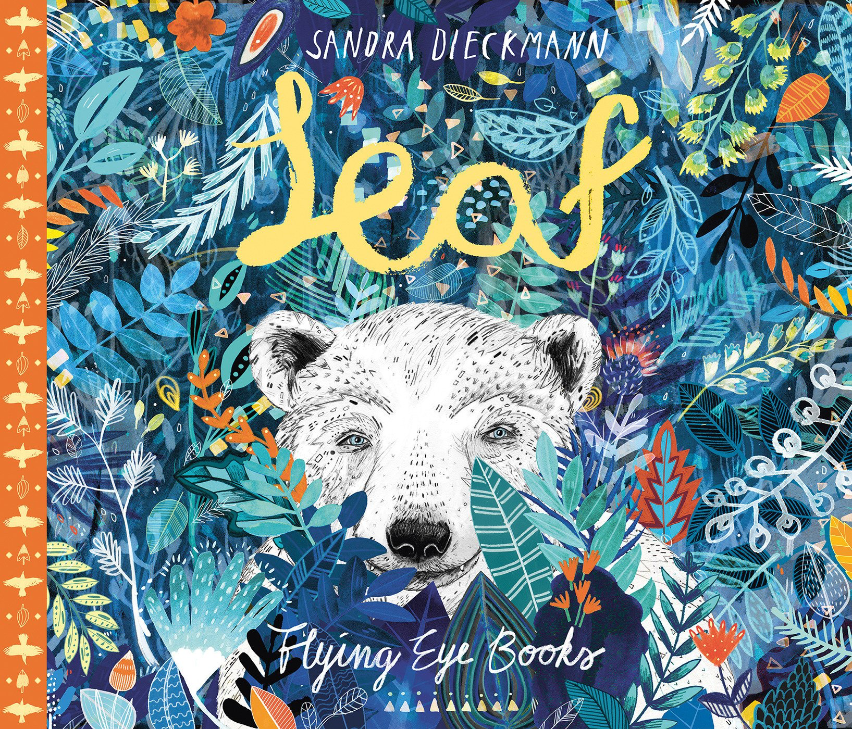 |  |  | 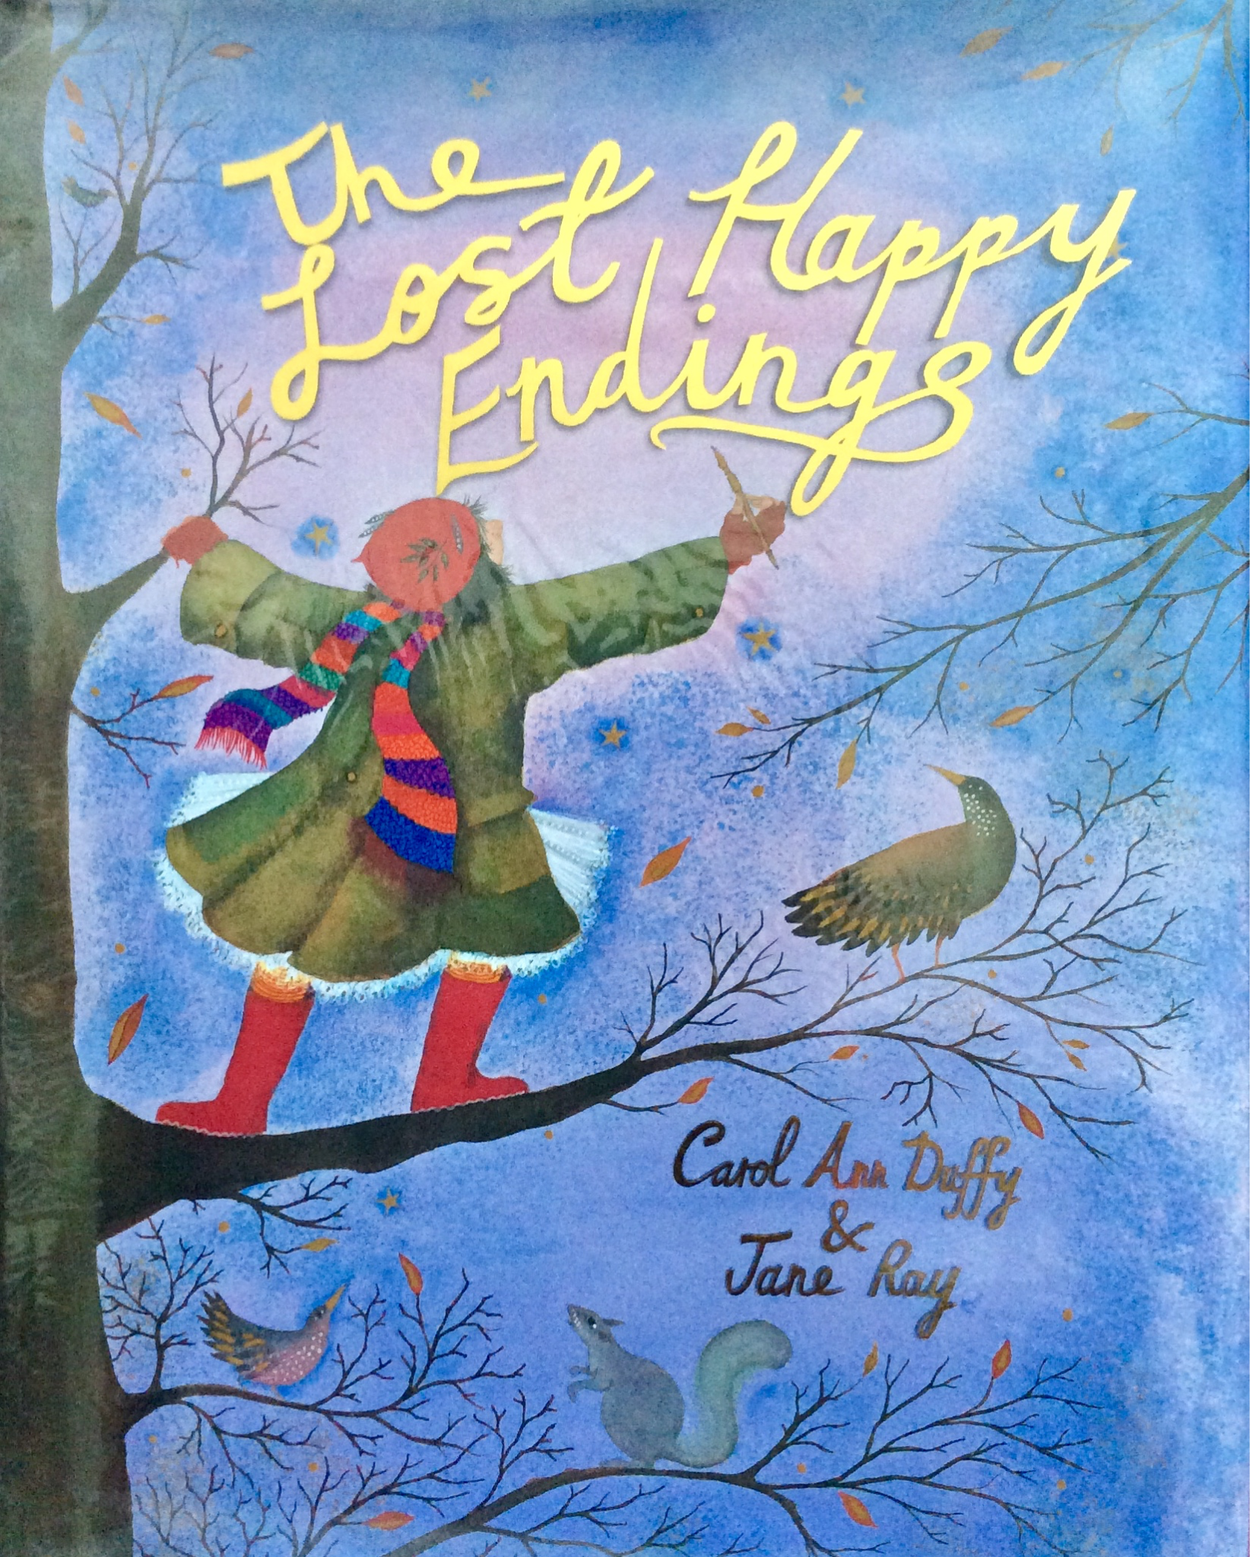 |  | 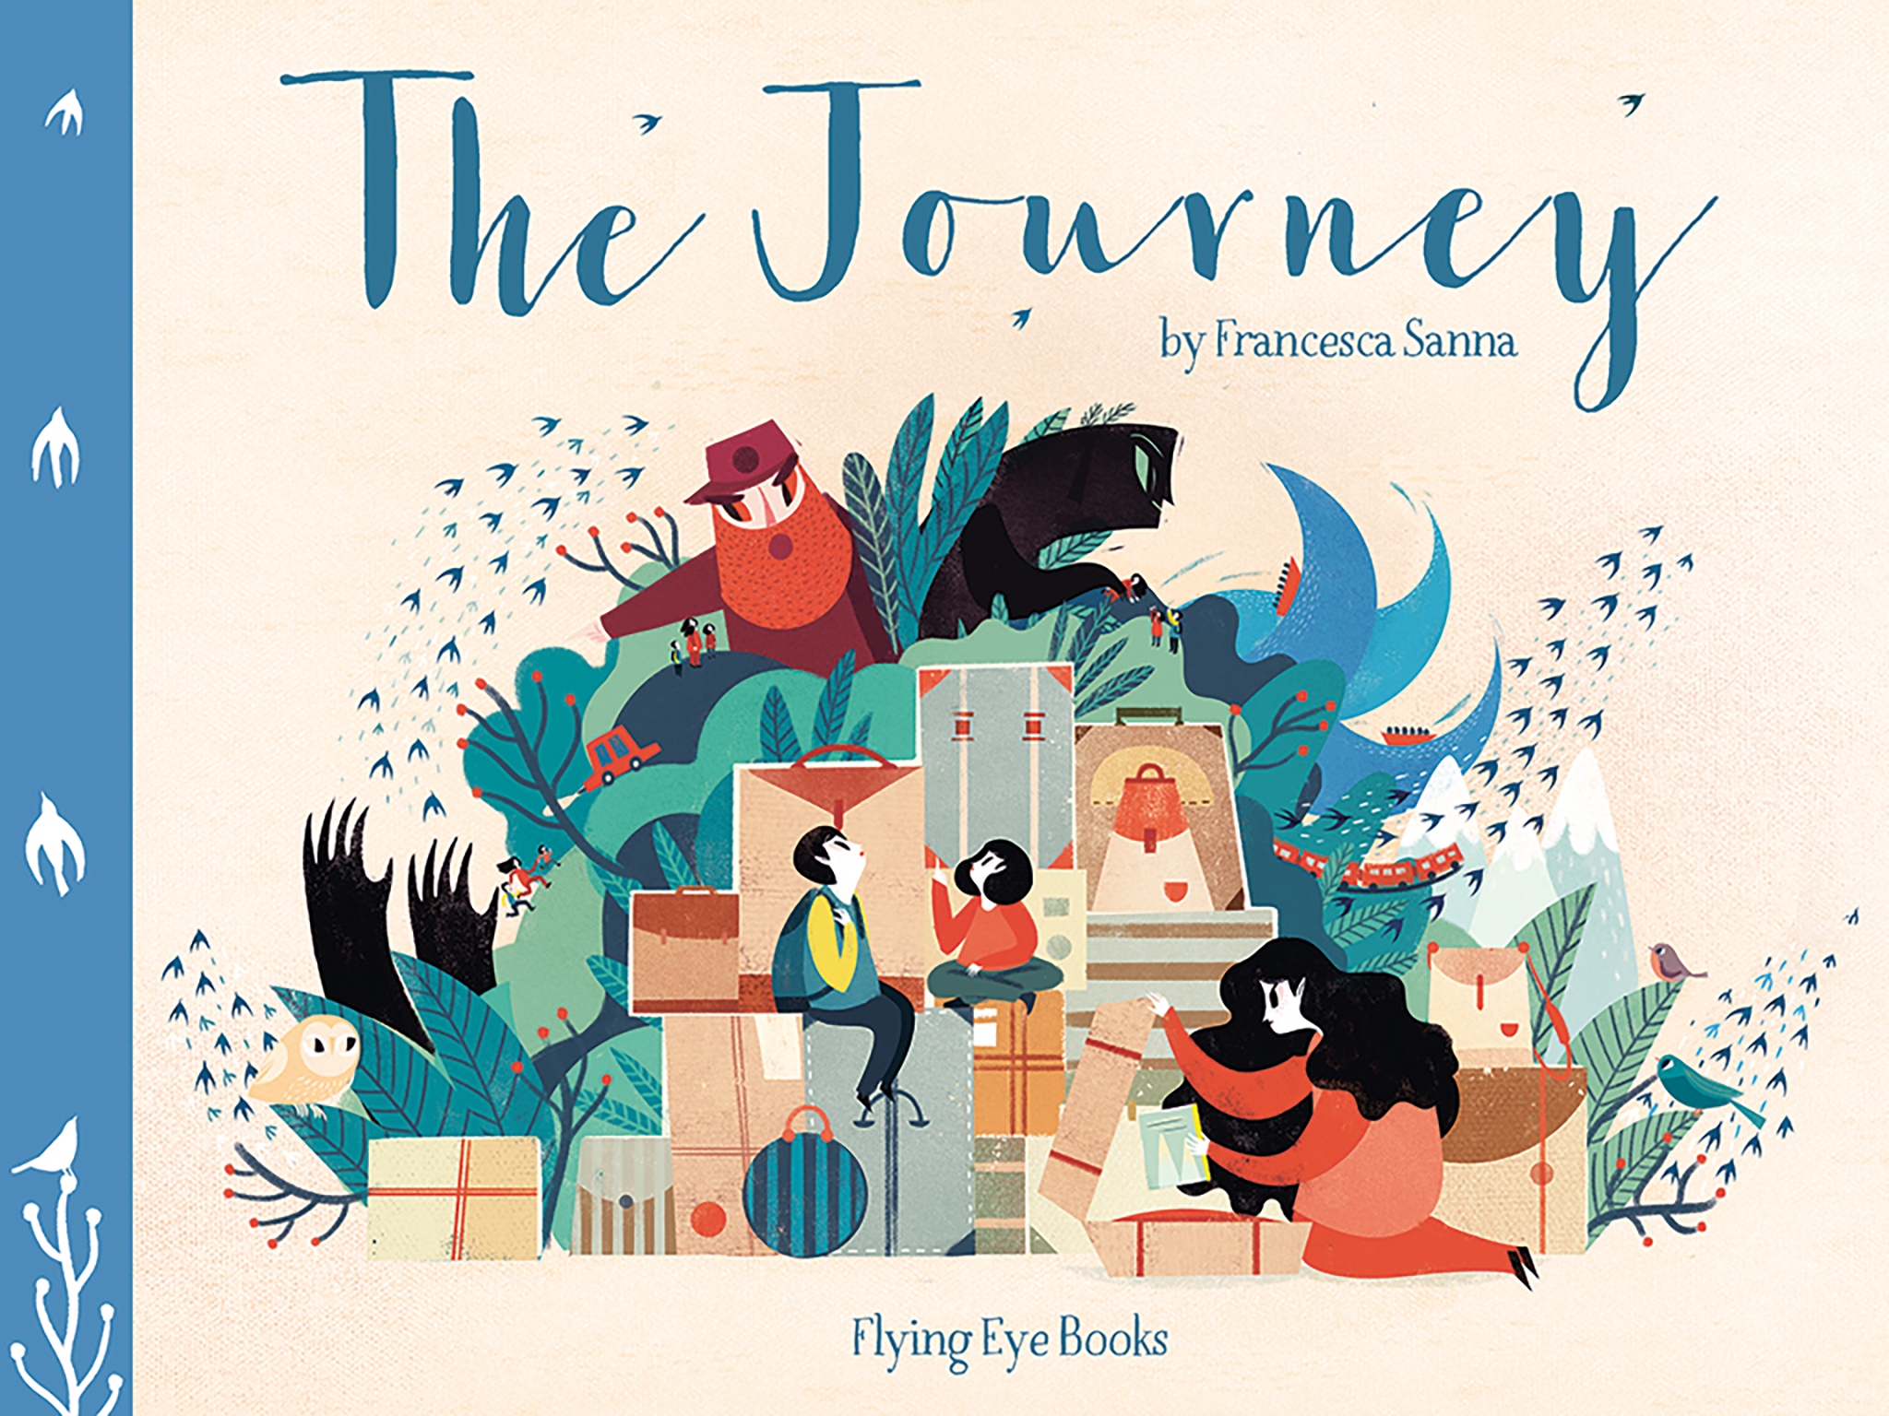
English | Leaf  Narrative - Outsider Narrative  Information - Polar Bears |  |  | The Lost Happy Endings  Narrative - Twisted Narrative  Persuasion - Letter |  | The Journey  Narrative - Refugee Narrative  Recount - Diary
Mathematics  (Including cross-curricular) | Number: Mental maths, place value, add, subtract, multiply & divide  Measurement: Perimeter & Length  Science: Measures- length cm / mm(body parts)  History- Greek number system  Science:Venn diagram- sorting electrical appliances  IT&C : bar graphs, line graphs & pictograms  Science: 3D models of electricity pathway – nets  D&T: nets & measuring cm / mm sledges |  |  | Number: Mental maths,multiply & divide, fractions & decimals  Measurement: Area  Science: negative numbers - reading thermometers  Science: line graph of boiling water – prediction  Science: Measures,same volume different containers (liquids)  Science: Measures - weight ( making crispy cakes)  History: Roman honey buns – weight/capacity (D&T)  Science: measuring temp.- Using data loggers & time graphs of water being heated |  | Number: Mental maths, all operations  Measuring: Money & Time  Geometry: Shape, symmetry, angles, position & direction  Statistics: Revisit & deepen Bar & time graphs & collecting data (Mini beast hunt)  Science: measuring sound - Using data loggers  Science: Measures- length cm / mm (string telephones ) & sound- data loggers  Geography: Rivers - Collecting & presenting data (river lengths) Measures collecting river data (trip)  PE : Measures- perimeter & scale (tennis court)  PE: Athletics- length m / cm
Science | Animals, including humans  Humans and some other animals have skeletons and muscles for support, protection and movement.  Construct and interpret a variety of food chains, identifying producers, predators and prey. |  | Electricity  Identify common appliances that run on electricity.  Construct a simple series electrical circuit, identifying and naming its basic parts.  Identify whether or not a lamp will light in a simple series circuit.  Recognise that a switch opens and closes a circuit and associate this with whether or not a lamp lights in a simple series circuit.  Recognise some common conductors and insulators, and associate metals with being good conductors. | States of matter  Compare and group materials together, according to whether they are solids, liquids or gases.  Observe that some materials change state when they are heated or cooled, and measure or research the temperature at which this happens in degrees Celsius (°C)  Identify the part played by evaporation and condensation in the water cycle and associate the rate of evaporation with temperature |  | Living things & their habitats  Recognise that living things can be grouped in a variety of ways.  Explore and use classification keys to help group, identify and name a variety of living things in their local and wider environment.  Recognise that environments can change and that this can sometimes pose dangers to living things  Sound - Science Week  Identify how sounds are made, associating some of them with something vibrating.  Recognise that vibrations from sounds travel through a medium to the ear.  Find patterns between the pitch of a sound and features of the object that produced it.  Find patterns between the volume of a sound and the strength of the vibrations that produced it.  Recognise that sounds get fainter as the distance from the sound source increases.
Design & Technology |  |  | Rudolph sleigh  (Electrical circuits) | Moving History Book  (Romans) |  | Food  Dips and Dippers
Computing | PM 4.2 Online safety  (4 weeks)  PM 4.1 Coding  Coding, robots & gaming - Romulus & Remus |  | PM 4.6 Animation Wallace & Grommit  (3 weeks)  Digital art-Christmas calendars (2 weeks) | PM 4.3 Spreadsheets  (5 weeks) | Data logging - Temperature sensors - linked to Science.  PM 4.7 Effective searching(3 weeks) | PM 4.4 Writing different purposes - newspaper  (3 weeks)  Sound – Revisit & deepen data logging - sensors  Modelling & simulations – conductors and simulators – MakeyMakey (Revisit & deepen Electricity) | PM 4.5 Logo  (4 weeks)  PM 4.8 Hardware  (2 weeks)
History | Ancient Greeks  Ancient Greece – a study of Greek life and achievements and their influence on the western world  The legacy of Greek culture (art, architecture or literature) on later periods in British history, including the present day |  |  | Romans  Julius Caesar’s attempted invasion in 55-54 BC the Roman Empire by AD 42 and the power of its army successful invasion by Claudius and conquest, including Hadrian’s Wall British resistance, for example, Boudica ‘Romanisation’ of Britain: sites such as Caerwent and the impact of technology, culture and beliefs, including early Christianity
Geography |  |  |  | Escape from Pompeii  Describe and understand key aspects of physical geography - volcanoes, earthquakes  Revisit and deepen human/physical geography understanding.  Use maps atlases globes & digital/computer mapping to locate countries and describe features studied. Revisit and deepen atlas and mapping skills.  Describe and understand key aspects of physical geography: volcanoes, earthquakes. Describe and understand key aspects of physical and human geography, including: types of settlement and land use, economic activity including trade links, and the distribution of natural resources including energy, food, minerals & water (e.g.Why did the Romans want these?) |  | Europe: the holiday destination  NC-understand geographical similarities and differences through the study of human and physical geography of a region in a European country  - use maps, atlases, globes and digital/computer mapping to locate countries and describe features studied  -use the eight points of a compass, four -figure grid references, symbols and key to build their knowledge the wider world  identify the position and significance of latitude, longitude, Equator, Northern Hemisphere, Southern Hemisphere, the Tropics of Cancer and Capricorn, Arctic and Antarctic Circle, the Prime/Greenwich Meridian and time zones (including day and night)
Art | Printing  Greek shapes and patterns |  |  |  | Sculpture and painting  Roman pottery |  | Painting and drawing  Landscape and architecture.
Music  PM 4.9 Making Music  (4 weeks) | Mamma Mia  Pop  ABBA’s music |  | Glockenspiel Stage 2  Mixed Styles  Exploring and developing playing skills using the glockenspiel | Stop!  Grime  Writing lyrics linked to a theme | Lean On Me  Gospel  Soul/Gospel music and helping one another | Blackbird  The Beatles/Pop  The Beatles, equality and civil rights | Reflect, Rewind and Replay  Classical  The history of music, look back and consolidate your learning, learn some of the language of music
Spanish | A new start  *Greetings  *Numbers  *Colours |  | The calendar and celebrations  *Learning Autumn colours.  *Days/ months. | Animals I like and don't like  *Epiphany celebrations.  *Masculine/ feminine.  *Animals. | Carnival and playground games  *Carnival & playground games.  *Easter celebrations.  *Revisit days, months, numbers and colours. | Breakfast, fruit nouns, hungry giant  *Nouns for fruit and vegetables.  *Nouns for breakfast foods. | Going on a picnic  *To ask and answer where they live.  *Explore names of locations for a picnic.
Physical Education  Games - Strike/field (Lancs -cricket)? | Real gym 1  Games - Invasion (Warrington Wolves- SKYTRY rugby) | Real PE 5  Dance– Greeks |  | Real Gym 2  Games - Strike/Field  (Lancs cricket) | Games - Strike/field  Dance – Roman | Real PE 6  Games - Net Wall (Gary: Culcheth Tennis Club -tennis) | Athletics  SWIMMING
Religious Education  (How should we live our lives? Living the Faith) | Judaism  Do people need laws to guide them? | Hindu Dhama - What Hindus learn from Divali  (4th Nov 2021) |  | Christianity (God) - How and why might Christians use the bible? | Christianity (Jesus)  Is sacrifice important for religious life | Islam  Why do Muslims fast during Ramadan  (2nd Apr - 1st May 2022) | Christianity Church)  Love your neighbour
PSHEE  Jigsaw | Being me in my world | Celebrating difference  (including anti-bullying) |  | Dreams and goals | Healthy me | Relationships | Changing me  (including sex education)

