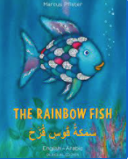
Y4 Curriculum Map– Sep 2021

 | Autumn Term |  |  | Spring Term |  | Summer Term
Theme | Ancient Greek Heroes  + Christmas Lights |  |  | Europe Past and Present! |  | A World of Water and Habitats
Subject | 1st half |  | 2nd half | 1st half | 2nd half | 1st half | 2nd half
Focus Texts: | 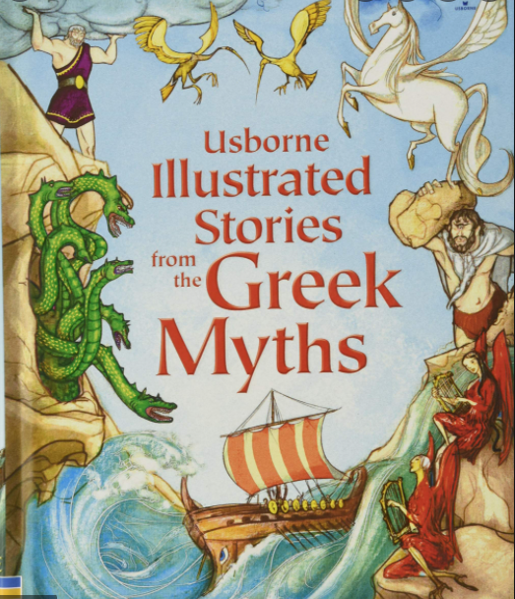 |  |  | 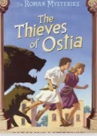
English | Aut 1  Non-fiction: Instructions -How to make a pair of wings  Fiction: Greek Myths & Legends and Stories that raise issues and dilemmas;  Aut 2  Poetry: based on The Trojan War in the style of The Highwayman  Non-fiction: Explanation texts (Wallace & Gromit linked to electricity)  +Non-fiction: Explanation texts Science- how a circuit works |  |  | Spr 1  Persuasive text: Letter to the emperor, Julius Caesar, to invade Britain or not.  Play script: A scene from Thieves of Ostia.  Spr 2  Non-fiction: Recount of Roman day  Poetry: Humorous poetry - themed work  (Romans)  S&L linked based writing: weather reports/eye witness accounts |  | Sum 1  Non-fiction : Minibeast newspaper report  Non-fiction: Science biography - Alexander Graham Bell  Sum 2  Fiction: Story linked to book on Rivers Rainbow fish to the rescue  Non-fiction: Information texts (Rivers)  Fiction: Cartoon strips (Trip)
Mathematics  (Including cross-curricular) | Number: Mental maths, place value, add, subtract, multiply & divide  Measurement: Perimeter & Length  Science: Measures- length cm / mm(body parts)  History- Greek number system  Science:Venn diagram- sorting electrical appliances  IT&C : bar graphs, line graphs & pictograms  Science: 3D models of electricity pathway – nets  PE: Athletics- length m / cm  D&T: nets & measuring cm / mm sledges |  |  | Number: Mental maths,multiply & divide, fractions & decimals  Measurement: Area  Science: negative numbers - reading thermometers  Science: line graph of boiling water – prediction  Science: Measures,same volume different containers (liquids)  Science: Measures - weight ( making crispy cakes)  History: Roman honey buns – weight/capacity (D&T)  Science: measuring temp.- Using data loggers & time graphs of water being heated |  | Number: Mental maths, all operations  Measuring: Money & Time  Geometry: Shape, symmetry, angles, position & direction  Statistics: Revisit & deepen Bar & time graphs & collecting data (Mini beast hunt)  Science: measuring sound - Using data loggers  Science: Measures- length cm / mm (string telephones ) & sound- data loggers  Geography: Rivers - Collecting & presenting data (river lengths) Measures collecting river data (trip)  Wimbledon: Measures- perimeter & scale (tennis court)
Science  (incl. DT) | Animals, including humans  (Grouping animals and Bones & Muscles |  | Electricity | States of matter  (Solids, liquids & gases) |  | Living things & their habitats (Revisit & deepen Grouping animals)  Sound - Science Week (Revisit & deepen links with Electricity)
 |  |  | D&T:Rudolph sleigh  (Electrical circuits)  design & evaluation process | D&T: Cookery Roman Party Menu - honey cakes  (Revisit & deepen design & evaluation process) |  | D&T:Pop up tree houses - Pop ups & levers  (Revisit & deepen design & evaluation process)
Information Technology | PM 4.2 Online safety  (4 weeks)  Coding, robots & gaming - Scratch - Romulus & Remus  (PM 4.1 Coding) |  | PM 4.6 Animation Wallace & Grommit  (3 weeks)  Digital art-Christmas calendars (2 weeks) | PM 4.3 Spreadsheets  (5 weeks) | Data logging - Temperature sensors - linked to Science.  PM 4.7 Effective searching(3 weeks) | PM 4.4 Writing different purposes - newspaper  (3 weeks)  Sound – Revisit & deepen data logging - sensors  Modelling & simulations – conductors and simulators – Makey Makey (Revisit & deepen Electricity) | PM 4.5 Logo  (4 weeks)  PM 4.8 Hardware  (2 weeks)
Geog/History  (incl. Art) | Ancient Greek study of their lives and achievements and influence on the western world. Understand geographical similarities and differences through the study of human and physical geography of a region in a European country. Use maps atlases globes & digital/computer mapping to locate countries and describe features studied. |  |  | Locate countries, using maps to focus on Europe (incl. Russia) concentrating on environmental regions, key physical/human characteristics, countries, and major cities. Revisit and deepen human/physical geography understanding.  Use maps atlases globes & digital/computer mapping to locate countries and describe features studied. Revisit and deepen atlas and mapping skills.  Describe and understand key aspects of physical geography: volcanoes, earthquakes. Describe and understand key aspects of physical and human geography, including: types of settlement and land use, economic activity including trade links, and the distribution of natural resources including energy, food, minerals & water (e.g.Why did the Romans want these?) |  | River systems-Describe & understand key aspects of physical geography: the water cycle. Use 8 points of a compass, 4-figure grid references, symbols and key (including the use of Ordnance Survey maps) to build their knowledge of the UK – link to river features. Use fieldwork to observe, measure, record and present the human and physical features in the local area using a range of methods, including sketch maps, plans and graphs, and digital technologies.Revisit and deepen human/physical geography understanding.
 | Art: Drawing & sculpture - Elgin Marbles or Greek architecture and clay tile. |  | Art: Digital art - calendars | Art : Sculpture and painting - Roman pottery clay models of Celts and Romans. Revisit and deepen sculptures (clay). |  | Art : Batik - Rainbow Fish  Revisit & deepen digital art - tropical fish  And printing - Polyprints of underwater plants/coral (background)
Music  PM 4.9 Making Music  (4 weeks) | Mamma Mia  (Popular Music) |  | Glockenspiel Stage 2  (Using C,D,E and F) | Stop!  (Rap/Grime) | Lean On Me  (Soul) | Blackbird  (The Beatles) | Reflect, Rewind and Replay  (Theory of Music)
Spanish | Me and  Parts of the Body  A simple sequence of questions and answers about myself, parts of the body |  | My School  Similarities between our school and one in Spain, places in a school, classroom objects | A Family Tree  Simple expressions to introduce family members, describing family members | Weather  Weather phrases and  Seasons  Simple weather phrases, link months to seasons and weather | Animals and Habitats  Animal descriptions, revisit parts of the body, simple sentences describing animal habitats | Summertime  Revisit weather phrases and asking about the weather,revisit fruit and introduce ice-cream flavours
Physical Education  Games - Strike/field (Lancs -cricket)? | Set4U: Real gym  Games - Invasion (Warrington Wolves- SKYTRY rugby) | Set4U:Games - Invasion  Dance– Greeks  & Real PE- 3  (3wks each) |  | Set4U: Real Gym  Games - Strike/Field  (Lancs cricket) | Set4U: Games - Strike/field  Dance – Roman  Real PE- 5  (3wks each) | Set4U: Real PE 6  Games - Net Wall (Gary: Culcheth Tennis Club -tennis) | Athletics  SWIMMING
Religious Education  (How should we live our lives? Living the Faith) | Judaism  Do people need laws to guide them? | Hindu Dhama - What Hindus learn from Divali  (4th Nov 2021) |  | Christianity (God) - How and why might Christians use the bible? | Christianity (Jesus)  Is sacrifice important for religious life | Islam  Why do Muslims fast during Ramadan  (2nd Apr - 1st May 2022) | Christianity Church)  Love your neighbour
PSHEE  Jigsaw | Being me in my world | Celebrating difference  (including anti-bullying) |  | Dreams and goals | Healthy me | Relationships | Changing me  (including sex education)

