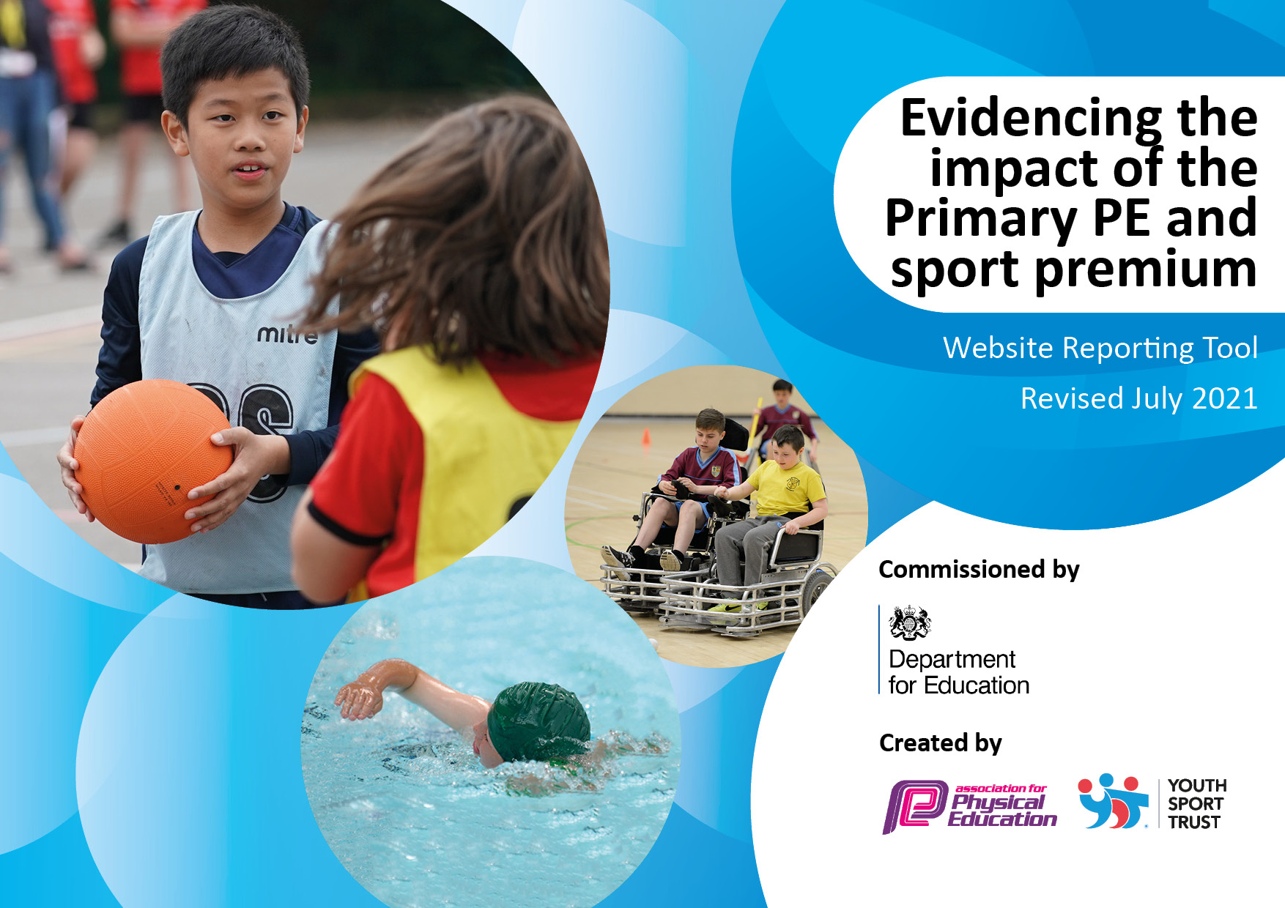
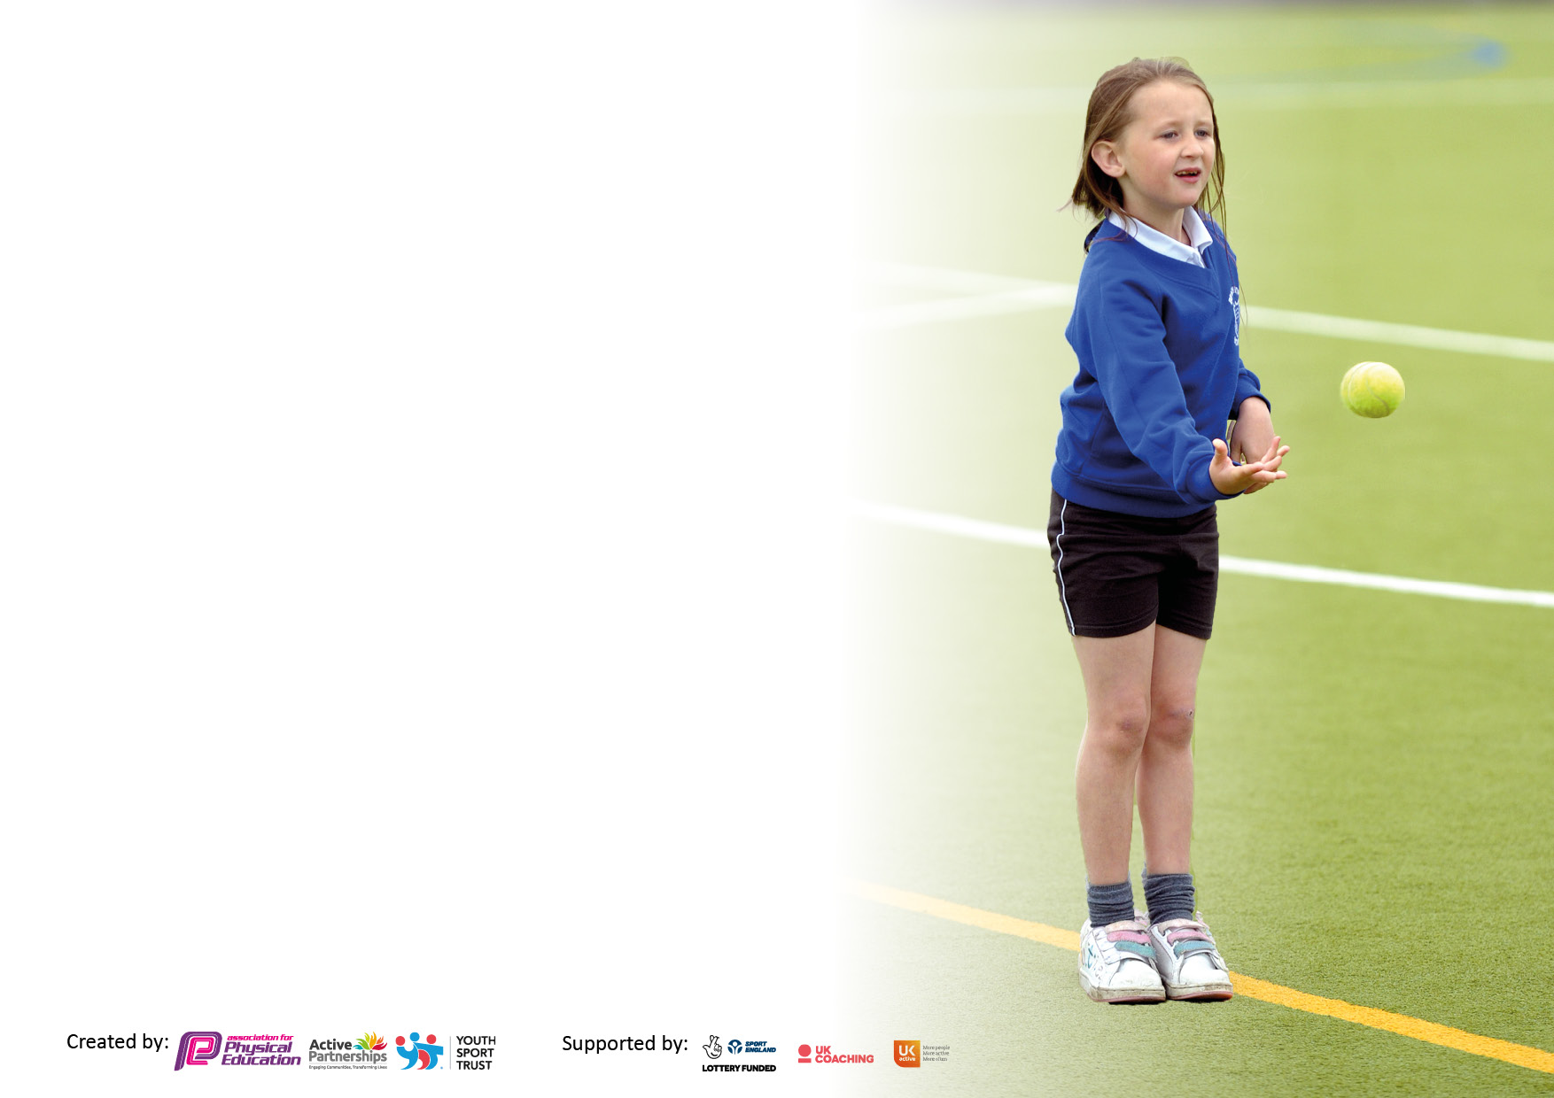

It is important that your grant is used effectively and based on school need. The Education Inspection Framework makes clear there will be a focus on ‘whether leaders and those responsible for governors all understand their respective roles and perform these in a way that enhances the effectiveness of the school’.

Under the Quality of Education Ofsted inspectors consider:
Intent - Curriculum design, coverage and appropriateness
Implementation - Curriculum delivery, Teaching (pedagogy) and Assessment
Impact - Attainment and progress

To assist schools with common transferable language this template has been developed to utilise the same three headings which should make your plans easily transferable between working documents.

Schools must use the funding to make additional and sustainable improvements to the quality of Physical Education, School Sport and Physical Activity (PESSPA) they offer. This means that you should use the Primary PE and sport premium to:

- Develop or add to the PESSPA activities that your school already offer
- Build capacity and capability within the school to ensure that improvements made now will benefit pupils joining the school in future years
- The Primary PE and sport premium should not be used to fund capital spend projects; the school’s budget should fund these.

Pleasevisitgov.ukfortherevisedDfEguidanceincludingthe5keyindicatorsacrosswhichschoolsshoulddemonstrate animprovement.Thisdocumentwillhelpyoutoreviewyourprovisionandtoreportyourspend.DfEencouragesschools to use this template as an effective way of meeting the reporting requirements of the Primary PE and sport premium.

We recommend you start by reflecting on the impact of current provision and reviewing the previous spend.

Schools are required to publish details of how they spend this funding, including any under-spend from 2019/2020, as well as on the impact it has on pupils’ PE and sport participation and attainment. All funding must be spent by 31st July 2022.

We recommend regularly updating the table and publishing it on your website throughout the year. This evidences your ongoing self-evaluation of how you are using the funding to secure maximum, sustainable impact. Final copy must be posted on your website by the end of the academic year and no later than the 31st July 2021. To see an example of how to complete the table please click HERE.
Created by: Supported by:

Key achievements to date until July 2022: | Areas for further improvement and baseline evidence of need:
High quality, consistent teaching of a PE lesson each week.  Fully progressive PE curriculum that gives the children the opportunity to embed fundamental skills and then apply them into games in KS2.  Play leaders deliver games at lunchtime.  Strong links with local tennis, cricket and rugby.  High quality Healthy Lives week every year.  Development of staff CPD.  Y5 attend Bike-ability every year.  Daily mile and wake and shake.  Increased sport equipment on the playground and for lessons.  Competitions up and running again following COVID restrictions.  Attendance at a Dance competition  A range of extracurricular clubs up and running so that all children have the opportunity to take part | Attendance at a wider range of competitions  Assessment embedded  New staff confident with our PE curriculum  Purposeful playtimes  Active Learning throughout the day and throughout school

Details with regard to funding
Please complete the table below.

Total amount carried over from 2019/20 | £6,346
Total amount allocated for 2020/21 | £17,720
How much (if any) do you intend to carry over from this total fund into 2021/22? | £0
Total amount allocated for 2021/22 | £17,737
Total amount of funding for 2021/22. To be spent and reported on by 31st July 2022. | £17,737
Swimming Data
Please report on your Swimming Data below.

Meeting national curriculum requirements for swimming and water safety.

N.B. Complete this section to your best ability. For example you might have practised safe self-rescue techniques on dry land which you can then transfer to the pool when school swimming restarts.
Due to exceptional circumstances priority should be given to ensuring that pupils can perform safe self rescue even if they do not fully meet the first two requirements of the NC programme of study
What percentage of your current Year 6 cohort swim competently, confidently and proficiently over a distance of at least 25 metres?  N.B. Even though your pupils may swim in another year please report on their attainment on leaving primary school at the end of the summer term 2021.  Please see note above | 100%
What percentage of your current Year 6 cohort use a range of strokes effectively [for example, front crawl, backstroke and breaststroke]?  Please see note above | 100%
What percentage of your current Year 6 cohort perform safe self-rescue in different water-based situations? | 100%
Schools can choose to use the Primary PE and sport premium to provide additional provision for swimming but this must be for activity over and above the national curriculum requirements. Have you used it in this way? | No

Action Plan and Budget Tracking
Capture your intended annual spend against the 5 key indicators. Clarify the success criteria and evidence of impact that you intend to measure to evaluate for pupils today and for the future.

Academic Year: 2020/21 | Total fund allocated: £17737 | Date Updated: 26.06.22
Key indicator 1: The engagement of all pupils in regular physical activity – Chief Medical Officers guidelines recommend that primary school pupils undertake at least 30 minutes of physical activity a day in school |  |  |  | Percentage of total allocation:
 |  |  |  | 5%
Intent | Implementation |  | Impact
Embed as much physical activity into the school day as possible. | 100% of the school take part in a minimum of 2 40 minute PE lessons a week. Additional lessons added in and active breaks in the classroom everyday/daily mile. | Nil | Children will be fit and healthy and will develop a passion for physical activity. | Continued monitoring of PE lessons through assessment, questionnaires and learning walks.
Provide a wide range of afterschool clubs - particularly targeting the least active. | PE lead to seek out the interests of the children with a questionnaire. PE lead will then seek out providers to deliver the clubs and send invitations to ch to attend. | Purple Gecko Youth Karate Club - £300  - £150  Legacy Health and Fitness -  + £240 | Children will have developed in terms of confidence. Their physical activity will have increased. Pathways for physical activity outside of school will have been highlighted to the children by providers. | Plan extra-curricular clubs for next academic year. Involve children in selection of extracurricular clubs.
Increase the levels of pupil fitness. | PE Lead to encourage Daily Mile for KS2 and reimplement Wake and Shake for the younger children.  PE Lead to organise GET SET Travel to Tokyo to encourage families to get active.  Whole school participation in Walk to School week. | Nil | Children and families will be involved in physical activity. The profile will be raised. Children’s physical and mental health will be improved. | Continue next academic year.
For children to be able to engage in a range of physical activities at play and lunchtimes. | Foam Javelins & foam balls for children to practice and consolidate skills in focused activities at lunchtimes. They will be used by our playground leaders in their sessions. | £138  £64 | Playtimes will be purposeful and behaviour will improve. | Continue to upskill children to deliver sessions at play and lunchtimes
Key indicator 2: The profile of PESSPA being raised across the school as a tool for whole school improvement |  |  |  | Percentage of total allocation:
 |  |  |  | 46%
Intent | Implementation |  | Impact
The children will develop fundamental skills, as well as skills linked to specific sports, through the delivery of a progressive curriculum. Staff will be confident and upskilled throughout the built in staff training provided and the well planned lessons which they will be delivering. | GET Set 4 PE | £660 | Children will be knowledgeable and skilled in the PE units they have participated in. They will develop a passion for physical activity. They will develop social skills through the focus on collaboration and teamwork. | Staff questionnaire at the end of the academic year to plan any support for next academic year.
Service Level Agreement provided by the Local Authority. LiveWire, Warrington School Sport Partnership and The Warrington Wolves Charitable Foundation work together to provide schools with high quality support and a menu of opportunities, including:  - Teaching and learning support  - Pupil achievement and progress  - Staff training and support  - Assessment and planning  - Health and wellbeing  - Safe practice in PE and sport  - Competition  Warrington Wolves rugby league coaching | Engagement with all aspects of the SLA | £2782 | Subject Leader, as well as class teachers, will have support  Pupils will have access to experience days and competitions  Expert coaching for rugby | Request to continue with the School Sports Partnership next academic year.
For all children to have opportunities to be active and challenged physically at playtimes | Trim trail playground equipment | £4799 | Purposeful, playtimes where behaviour is at least good and children are able to be active for sustained periods of time. | Maintain equipment

Key indicator 3: Increased confidence, knowledge and skills of all staff in teaching PE and sport |  |  |  | Percentage of total allocation:
 |  |  |  | 21%
Intent | Implementation |  | Impact
For all staff to be confident and skilled in the delivery of PE. | SET4U Coaching - Staff development - autumn term | £3675 | When SET4U coaching left at the end of the autumn term staff were able to seamlessly transition to deliver effective PE lessons. | N/A
Subject Leader to be informed on national agendas for PE and this will then feed into school priorities | AfPE membership | £95 | Informed practise within school that links to national priorities | Continue with membership next year
Key indicator 4: Broader experience of a range of sports and activities offered to all pupils |  |  |  | Percentage of total allocation:
 |  |  |  | 10%
Intent | Implementation |  | Impact
We want our Y6 pupils to learn about physical activities from different cultures to deepen their understanding about the world around them and why physical activity is so important. | Capoeira Workshops | Funding  Allocated:  £480 | Our children had a learning experience that will stay with them long after they leave us. Many of the children felt enthused to try other martial arts as a result. | Sustainability and suggested next steps:  -Encourage the children to take part in further martial arts and make links with clubs in the community.
Many of our children take part in sporting extracurricular activities so we feel that a martial art club would be of benefit to them, in terms of their wellbeing and mental health. We want them to experience the focus required to engage in a martial art while having fun and improving fitness levels. | Purple Gecko Youth Karate Club | £300 | Children become passionate about physical activity. They are given information on pathways in the community where they can continue to take part in Karate sessions. | The children have been given details on clubs in the community that they can attend following participation in the club.
For the children to take part in a range of sporting activities. | Road 2 Tokyo Whole School Workshops | £495 | Children were enthused and the profile of physical activity was raised.
For the children to receive expert coaching to develop knowledge and skills of the sport of tennis. | Tennis Coaching | £383.16 | Children showed a good level of skill. They were enthusiastic and some took part in an extracurricular club. They have developed a pathway to take part in further tennis sessions at Culcheth Tennis Club. | Teachers support sessions to allow them to implement coaching sessions in future
For the children to have the necessary and safe equipment to take part in sports sessions regardless of the weather. | Additional balls for children to use in extra-curricular clubs | £192 | The foam balls allowed our Dodgeball club to take place indoors. | Resources within school to allow staff to continue clubs if necessary

Key indicator 5: Increased participation in competitive sport |  |  |  | Percentage of total allocation:
 |  |  |  | 1%
Intent | Implementation |  | Impact
For our UKS2 children to be able to take part in an Athletics competition after qualifying for town finals. | Coach to take children to Birchwood Athletics Town Final Competition | £190 | The children had a fantastic experience. Their confidence and skills improved as a result. | Take part in the Culcheth Athletics competition next year. Plan competitions for next academic year.

Signed off by
Head Teacher: | N. Hughes
Date: | 29/07/22
Subject Leader: | A Durr
Date: | 30/07/22
Governor: | L Davis
Date: | 31/07/22

