EYFS Foundation Subject Overview 2021/22
All activities and learning objectives are possible lines of development. Children’s next steps and interests will be the focus of the day to day activities in the classroom.

 | Autumn Term |  | Spring Term |  | Summer Term
Term | Autumn One | Autumn Two | Spring One | Spring Two | Summer One | Summer Two
Topic | All About Me | Cold as Ice | Imagine and Invent | Food Glorious Food | Living Things | Journeys
Core Text | 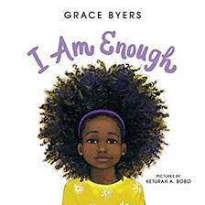 | 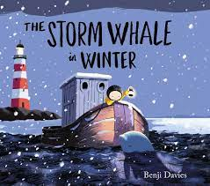 | 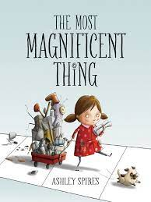 | 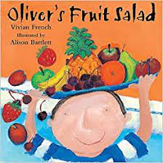 | 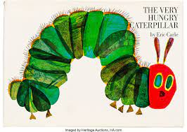 | 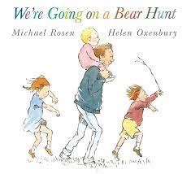
Supporting Texts | The Colour Monster  The Dot  The Day The Crayons Quit  The Little Red Hen  Pumpkin Soup | Smoot - The Rebellious Shadow  Lost and Found  Blown Away  Snowflakes  Christmas themed stories | It’s Not a Box  What Floats in a Moat?  Mrs Armitage on Wheels  Mrs Armitage and the Big Wave | The Lighthouse Keeper’s Lunch  Oliver’s Vegetables  The Enormous Turnip  Jack and the Beanstalk  The Tiger Who Came For Tea | The Flower  Mad About Minibeasts  Superworm  What the Ladybird Heard | The Train Ride  We’re Going on a Lion Hunt  Mr Gumpy’s Outing  Little Red Riding Hood
Events | Harvest  Visit to the Methodist Church/walk around local area  Parents Evenings | Halloween  Bonfire Night  Anti-bullying week  Remembrance  Christmas | Chinese New Year  Children’s Mental Health Awareness  Safer Internet Day  Valentines Day | World Book Day  Fairtrade Fortnight  Parents Evenings  Mothers Day  Jim Jam Jog  Easter  Visit to a farm -- growing food focus | Science Week  Walk to School Week | Fathers Day  Healthy Lives Week & Sports Day  Reception Sunshine Assembly  Transition  Summer Fair
Communication (Phase One phonics)  and Language - | Listen to others in one-to-one or small groups, when conversation interests them. - child-initiated play  Listens to familiar stories with increasing attention and recall. Story time and continuous provision areas  Joins in with repeated refrains and anticipates key events and phrases in rhymes and stories. - Nursery rhymes | Is able to follow directions (if not intently focused). Daily routines  Shows understanding of prepositions such as under, on top, behind by carrying out an action or selecting correct picture - Link to mathematical vocabulary & Rosie’s Walk  Extends vocabulary, especially by grouping and naming, exploring the meaning and sounds of new words. Story time, new vocabulary from stories planned and revisited throughout the year  Uses language to imagine and recreate roles and experiences in play situations. - Child-initiated play, role play and small world areas | Uses talk in pretending that objects stand for something else in their play e.g. This box is my castle. - Explanations of what they have planned/created in the junk modelling area.  Understands questions such as who; why; when; where and how - Focus on questions through planned theme Imagine and Invent  Links statements and sticks to a main theme or intention. | Listens and responds to ideas expressed by others in conversations or discussions. - carpet time, circle time, child-initiated play  Develop their own narratives and explanations by connecting ideas and events.  Uses talk to connect ideas, explain what is happening and anticipate what might happen next, recall and relive past experiences.  Introduces a narrative or storyline into their play. Child-initiated play, role play and small world areas | Listen attentively and respond to what they hear with relevant questions, comments, and actions when being read to and during whole class discussions and small group interactions .  Make comments about what they have heard and ask questions to clarify their understanding - child-initiated play, carpet time, adult led activities  Hold conversation when engaged in back-and-forth exchanges with their teachers and peers - child-initiated play, carpet time, adult led activities | Able to follow a story without pictures or props. - Story time - possibly introduce a chapter book.  Express their ideas and feelings about their experiences using full sentences, including the use of past, present and future tenses and making use of conjunctions, with modelling and support from teachers - Children talk about a journey that they have been on. Photographs used as a prompt.
Literacy | Understand the 5 key concepts about print  Spot and suggest rhyme  Count or clap syllables in words  Recognise words with the same initial sound (Phase One phonics)  Engage in extended conversations about stories, developing new vocabulary  Use some print knowledge in early writing. For example: writing a pretend shopping list that starts at the top of the page; writing ‘m’ for mummy. - continuous provision writing opportunities modelled and supported by adults  Write some or all of their name - name writing and family member labels | Continue a rhyming string and identify alliteration  Hear and say the initial sound in words  (Phase One phonics)  Begin to recognise some written names of peers, siblings or ‘Mummy’ or ‘Daddy for example  Read individual letters by saying the sounds for them  Begin to blend sounds together  Know which letters represent some sounds  (Phase Two Phonics)  Write some letters accurately - caption writing linked to phonics  Speech bubbles - link to focus text  Continuous Provision Writing Opportunities modelled and supported by adults | Begin to segment the sounds in simple words and blend them together and know which letters represent some of them  Begin to link sounds to some frequently used digraphs e.g. sh, th, ee  Enjoys creating texts to communicate meaning for an increasingly wide range of purposes, such as making greeting cards, tickets, lists, invitations, and creating their own stories and books with images and sometimes with words, in print and digital formats  Writing labels on their plan  Writing a list of materials  Write instructions for how to make... | Start to link sounds to letters, naming and sounding the letters of the alphabet  Begin to read some high frequency words, and to use developing knowledge of letters and sounds to read simple phonetically decodable words and simple sentences  Includes everyday literacy artefacts in play, such as labels instructions, signs envelopes etc.  Enjoys creating texts to communicate meaning for an increasingly wide range of purposes, such as making greeting cards, tickets, lists, invitations, and creating their own stories and books with images and sometimes with words, in print and digital formats  How to write a recipe | Say a sound for each letter of the alphabet and at least 10 digraphs  Read words consistent with their phonic knowledge by sound- blending  Read aloud simple sentences and books that are consistent with their phonic knowledge, including some common exception words  Write recognisable letters, most of which are correctly formed  Write simple phrases that can be read by themselves and others  Spell words by identifying sounds in them and representing the sounds with a letter or letters  Life cycle of a butterfly  acrostic poems | Read aloud simple sentences and books that are consistent with their phonic knowledge, including some common exception words  Write simple phrases that can be read by themselves and others  Story writing will be the focus this half term
Maths  White Rose SoL | BASELINE  Match  Sort  Compare amount  Compare size, mass and capacity  Explore pattern | Introducing 1 and 0  Representing 1, 2, 3  Comparing 1, 2, 3  Introduce 2  Composition 1, 2, 3  Introduce 3  Circles and Triangles  Spatial awareness  Introduce 4  Introduce 5  1 more/1 less  Comparing shapes  Night/Day & Time | Introducing zero  Comparing numbers to 5  Composition of 4 & 5  Compare mass (2)  Compare capacity (2)  6, 7, & 8  Making pairs  Comparing 2 groups  Length & height  Time | 9 & 10  Comparing numbers to 10  Bonds to 10  3-D shape  Pattern (2)  ASSESSMENT  SPRING CONSOLIDATION | Building numbers beyond 10  Counting patterns beyond 10  Spatial reasoning (1)  Match, rotate, manipulate  Adding more  Taking away  Spatial reasoning (2)  Compose and decompose | Doubling  Sharing and Grouping  Even and Odd  Spatial reasoning (3)  Visualise and Build  Deepening understanding  Patterns and Relationships  Spatial reasoning (4)  Mapping
Understanding the World  Enhancing Texts |  | 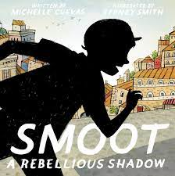 | 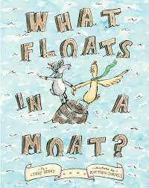 |  | 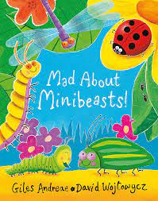 | 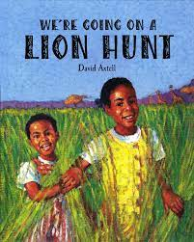
Understanding the World | Remembers and talks about significant events in their own experience - Family photo  Talk about members of their immediate family and community - draw pictures of themselves and family members  Name and describe people who are familiar to them - invite familiar people in to talk to the children e.g. nurses/doctors/police etc  Understand that some places are special to members of their community - visit the Methodist Church/walk around local area  Recognise that people have different beliefs and celebrate special times in different ways - link to RE  Understand the effect of changing seasons on the natural world around them - autumn. | Recognise some similarities and differences between life in this country and life in other countries. - Polar regions/Arctic - how do animals keep warm? Blubber experiment  Understand some important processes and changes in the natural world around them - Shadows - Smoot the Rebellious shadow/Melting and freezing - how can we melt the ice to free the characters? (Link to focus stories)  Understand the effect of changing seasons on the natural world around them - winter | Materials - Explore different materials and their properties in Investigation Area  Floating and sinking - What Floats in a Moat focus text and activity  Knows some similarities and differences between things in the past and now, drawing on their experiences and what has been read in class - Mrs Armitage stories, non fiction texts about inventors  Understand the past through settings, characters, and events encountered in books read in class and storytelling.  Understand the effect of changing seasons on the natural world around them - winter | Make observations of animals and plants and explain why some things occur, and talks about changes - Grow fruits and vegetables in our outdoor area. What do they need to grow?  Know some similarities and differences between the natural world around them and contrasting environments, drawing on their experiences and what has been read in class. - Different climates for fruit and vegetable growth - Where do fruits and vegetables grow? Look at maps and the globe and watch videos of how we get some of the fruits and vegetables that we eat.  Understand the past through settings, characters, and events encountered in books read in class and storytelling. The Tiger Who Came For Tea  Understand the effect of changing seasons on the natural world around them - spring | Explore the natural world around them, making observations and drawing pictures of animals and plants -Minibeast hunt, Minibeast habitats, observational drawings and small world exploration  Know some similarities and differences between the natural world around them and contrasting environments, - Bug hotel; what do we need to include for each minibeast? | Recognise some similarities and differences between life in this country and life in other countries. Explore the setting of the story We’re Going on Lion Hunt - How is it different to We’re going on a Bear Hunt? Explore climate, habitats, house and homes etc  Find Africa on a map or globe.  African animals and habitats - small world and non-fiction texts  Knows some similarities and differences between things in the past and now, drawing on their experiences and what has been read in class - Mr Gumpy stories  Understand the past through settings, characters, and events encountered in books read in class and storytelling.  Understand the effect of changing seasons on the natural world around them - summer
Computing - Purple Mash Scheme of Work | Introduce 2Simple city  2Paint - Self portrait | 2Simple city - Link to topic and interests | 2Simple city - Link to topic and interests | 2Count - Pictogram of favourite food | 2Simple city - Link to topic and interests  Introduce Beebots | 2Create a story
Expressive Arts and Design  Enhancing Texts | 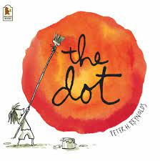 |  | 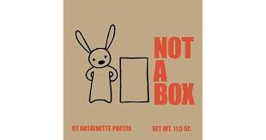
 | Explore, use and refine a variety of artistic effects to express their ideas and feelings - colour mixing, Kadinsky focus artist, circles, painting with powder paints/watercolour paints/poster paints  Nursery rhymes | Music focus - Vivaldi, Debussy - artwork and music inspired by the focus composers  Explore, use and refine a variety of artistic effects to express their ideas and feelings - printing - ‘Christmas/winter inspired’ artwork | Model making focus - plan and assemble vehicle of their own invention | Observational drawing focus - Drawing spring flowers using pastel crayons | Textiles - sewing focus - Butterfly sewing | Collage focus  African patterns & textiles
Personal, Social and Emotional Development  Jigsaw | Develops particular friendships with other children, which help them to understand different points of view and to challenge their own and others’ thinking  Jigsaw - Being Me in my World | Returns to the secure base of a familiar adult to recharge and gain emotional support and practical help in difficult situations  Is more aware of their relationships to particular social groups and sensitive to prejudice and discrimination.  Is more able to manage their feelings and tolerate situations in which their wishes cannot be met.  Jigsaw - Celebrating Difference | Is proactive in seeking adult support and able to articulate their wants and needs  Has a clear idea about what they want to do in their play and how they want to go about it.  Shows confidence in choosing resources and perseverance in carrying out a chosen task  Is aware of behavioural expectations and sensitive to ideas of justice and fairness  Jigsaw - Dream and Goals | Work and play cooperatively and take turns with others  Shows confidence in speaking to others about eir own needs, wants, interest and opinions in familiar group  Attempts to repair a relationship or situation where they have caused upset and understands how their actions impact other people.  Jigsaw - Healthy Me | Is increasingly socially skilled and will take steps to resolve conflicts with other children by negotiating and finding a compromise; sometimes by themselves and sometimes with support  Jigsaw - Relationships | Shows sensitivity to their own and to others needs.  Is able to regulate their behaviour according to their own and others’ feelings.  Shows independence, resilience and perseverance in the face of challenge  Jigsaw - Changing Me
RE | Christianity, Hinduism and Islam  Special times: How and why do we celebrate?  Recognise and describe special times or events for family and friends. UTW link |  | Christianity and Islam  Special stories: Why are some stories special? What special messages can we learn from stories? |  | Christianity, Hinduism and Islam  Special Places: What buildings and places are special to different people?
Physical Development | Shows understanding of the need for safety when tackling new challenges, and considers and manages some risks. - Classroom routines, expectations, support provided by adults in continuous provision  Shows understanding of how to transport and store equipment safely.  Practices some appropriate safety measures without direct supervision.  Experiments with different ways of moving, testing out ideas and adapting movements to reduce risk - Outdoor area, adventure trail, den making/obstacle course equipment | Negotiates space successfully when playing racing and chasing games with other children, adjusting speed or changing direction to avoid obstacles.  Use large and small equipment to explore travelling like Rosie and the fox. Look at bringing to life prepositions from the text such as over, under, across, above, below, around, through and work out ways of interacting with equipment or around a space.  Shows a preference for a dominant hand. - Phase 2 Phonics  Beginning to use anticlockwise movements and retrace vertical lines. - Phase 2 Phonics | Shows understanding of the need for safety when tackling new challenges, and considers and manages some risks. Classroom routines, expectations, support provided by adults in continuous provision  Shows understanding of how to transport and store equipment safely.  Practices some appropriate safety measures without direct supervision.  Uses simple tools to effect changes to materials. Handles tools, objects, construction and malleable materials safely and with increasing control.  Beginning to show accuracy and care when drawing | Shows some understanding that good practices with regard to exercise, eating, sleeping and hygiene can contribute to good health. - Healthy Me Jigsaw theme  Provide small- and large scale equipment to support children in moving in different ways e.g. navigating an obstacle course with cones, crawling through tunnels, climbing frames and slides, skipping, spinning hoops, throwing and catching  Investigate different ways of moving and travelling.  Travel with confidence and skill around, under, over and through balancing and climbing equipment. | Demonstrate strength, balance and coordination when playing. Outdoor area, adventure trail, den making/obstacle course equipment  Move energetically, such as running, jumping, dancing, hopping, skipping and climbing. - Dance focus in PE | Jumps off an object and lands appropriately.  Negotiates space successfully when playing racing and chasing games with other children, adjusting speed or changing direction to avoid obstacles.  Shows increasing control over an object in pushing, patting, throwing, catching or kicking it.  Watch African dancers
PE | Real PE – Unit 1 personal skills, coordination & static balance  Real Gym - Shape: At Home | Real PE - Unit 2 social skills, balance to agility & seated balance  Dance - Creative Steps: Seasons - Autumn and Winter | Real PE – Unit 3 cognitive skills, dynamic balance & small base balance  Real Gym - Flight: Park Life | Real PE – Unit 4 creative skills, coordination ball skills & counter  balance in pairs  Real Gym - Rotation: Toy Box | Real PE – Unit 5 physical skills, coordination with equipment,  & agility: reaction & response  Coaching - multi skills  Dance: Creative Steps: Growth and Change- The Hungry Caterpillar | Real PE – health & fitness, agility ball chasing & floor work  balancing  Real Gym - Travel: Jungle
Spanish | Hello and Goodbye | Greetings | Counting  1-10 | Counting  11-20 | Colours | 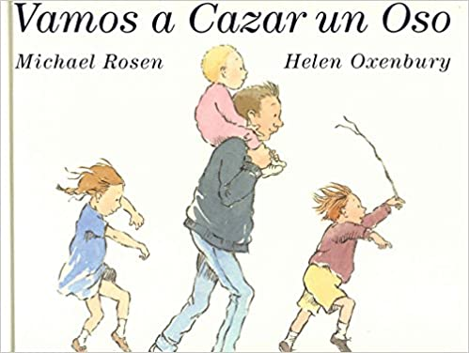
Music | Me!  - explore: growing, homes, colour, toys, how I look | My Stories  - explore: using your imagination, Christmas, Festivals, Fairies, Pirates, Treasure, Superheroes, Let's pretend, Once upon a time | Everyone!  - explore: family, friends, people and music from around the world | Our World  - explore: animals, jungle, minibeasts, night and day, sand and water, seaside, seasons, weather, sea, space | Big Bear Funk  - learn about the interrelated dimensions of music through singing, improvising and playing classroom instruments | Reflect, Rewind and Replay  Consolidation of learning and contextualising the history of music.

