Parents’ Evening Booking System

Our upcoming parents’ evening will be managed using SchoolPing – Our paperless school-to-parent communication system. Parents Evening booking will go live at 5pm tomorrow, Monday 31st October.
As a parent/carer you can simply book your appointment(s) directly through the SchoolPing mobile app, or on the web using an internet browser.

How to receive the booking form

The booking form will be sent in the form of a SchoolPing message. The message will be delivered to you one of two ways:

SchoolPing app (recommended)
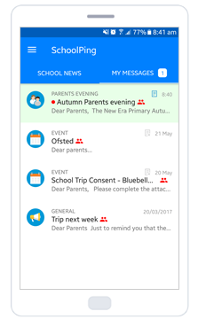

- We recommend that all parents with smartphones download and install the SchoolPing app- The app is free and can be downloaded onto Apple and Android devices.
- The SchoolPing app will notify you on your smartphone when a message is received
- All messages and their attachments can be read and managed directly from within the app
- When opening the SchoolPing app, you can find the parents’ evening messages in your ‘My Messages’ inbox

Email

If you are not logged into the SchoolPing app when we send out the parents’ evening booking form, then the message will be sent to your email address – this will be an email address we have stored for you on our system.
The email will include a Web Viewer link to allow you to open the parents’ evening booking form on the web.

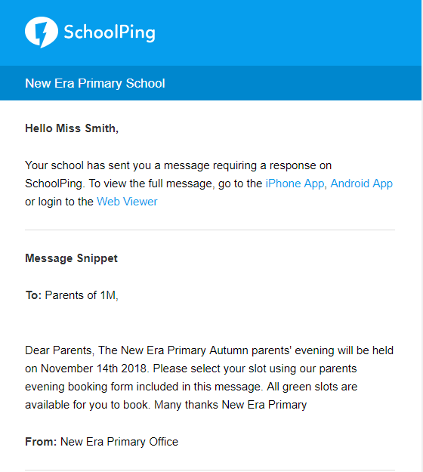

How to book your appointment

Booking with the SchoolPing app

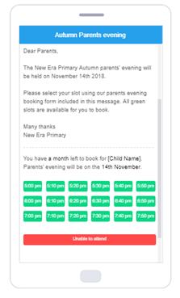

The parents’ evening booking form is included directly within the SchoolPing message.
Simply choose an appointment from the available green slots.
If you are unable to attend, there is a large Unable to attend red button to notify the school.

Booking your appointment on the web

SchoolPing messages can also be accessed on the web with an internet browser.
A link to the SchoolPing web login link has been added to the school website at www.twissgreen.net or can be provided to you by the school office.
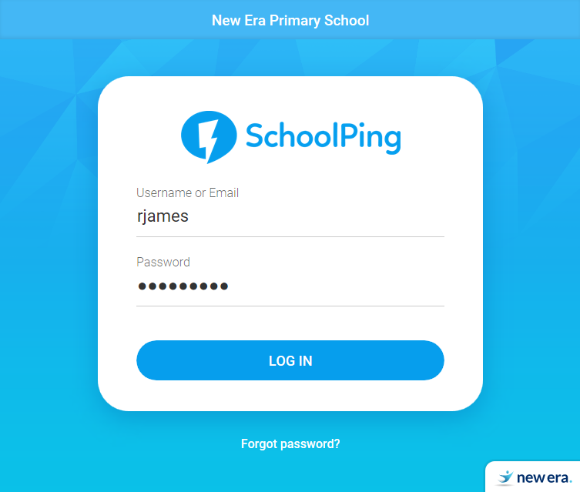

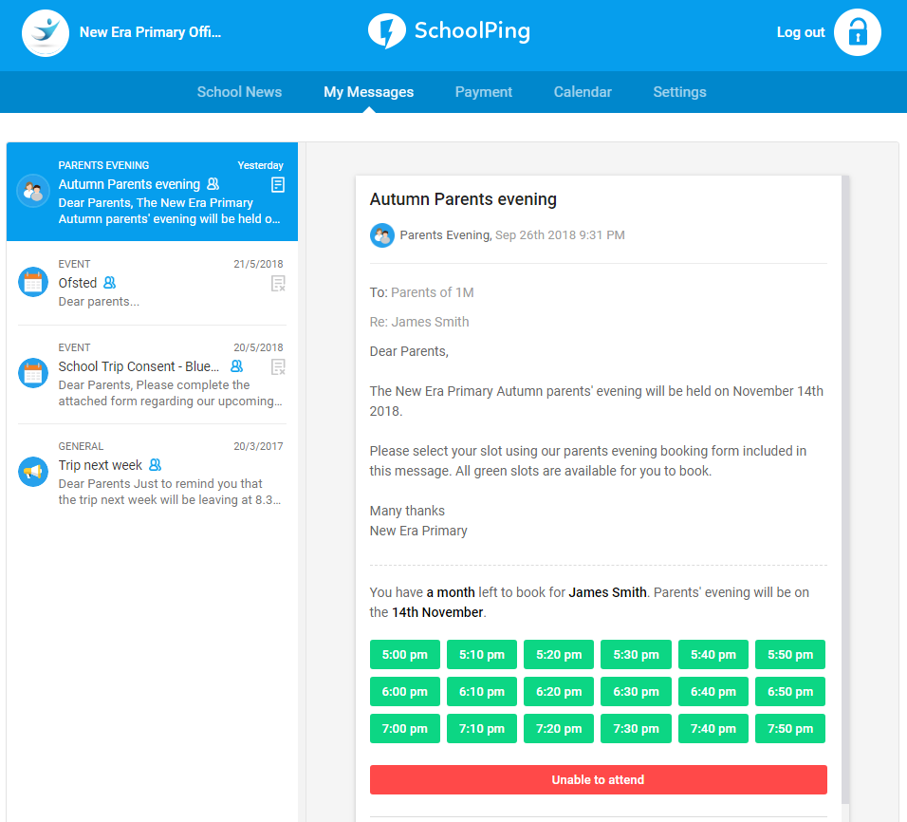

The Booking Deadline Date

The parents’ evening booking form will have a booking deadline date, which in this case is Monday 7th November. If you fail to book your appointment by this date (or do not have access to the internet or app), contact the school office who can help book a slot on your behalf.

FAQ

Can I cancel or change my booking?

Yes.
Parents can choose to remove their own bookings, and re-book if necessary, directly from within the app.

Can I add my appointment to my calendar?

Once you have booked your slot, the date and time will be added to your SchoolPing calendar as a reminder. Your calendar can be accessed by going to the SchoolPing app menu > Calendar.
Calendar events can also be added to a personal calendar on your mobile device:
- Find your parents’ evening appointment in the SchoolPing calendar and click on it
- Choose the ‘ADD TO PHONE CALENDAR’

Can two appointments be booked for the same child?

In cases where there is need to book more than one appointment for the same child, contact the school office who can reserve a second time slot.

I do not have my SchoolPing username

Please contact the school office as soon as possible if you do not yet have your SchoolPing username/password.

