Year 5 Curriculum Overview 2021-2022
 | Autumn 1 | Autumn 2 |  | Spring 1 |  |  | Spring 2 | Summer 1 | Summer 2
 | Struggle – Invaders, Raiders and Settlers |  |  | Journey to North America |  |  |  | Mysterious Mayans | ‘Industrialisation’ – Local history study
English | - Invitations  - Report Writing (Newspaper reports)  - Setting descriptions  - Explanation text (How to Kill a Monster)  - Poetry – Kenning  - Narrative – Legend/ Myth  - Persuasive writing – Job description/advertisement |  |  | - Non-chronological report writing  - ‘Queen of the Falls’ diary entry  - Persuasive writing – tourism (North America)  - Newspaper reports (Barrel Leap)  - Poetry |  |  |  | - Explanation text – Pok-a-Tok  - Persuasive writing – Chichen Itza brochure  - Hero Twins narrative | - Narrative poetry linked to Lewis Carroll (Jabberwocky)  - Non-chronological report writing  - Play – describing an everyday scene in Industrial NW England
Literature Focus | 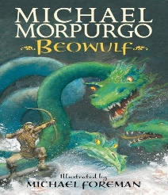 |  |  | 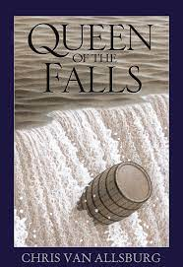 |  |  |  | 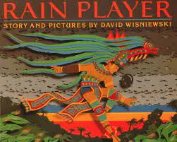 | 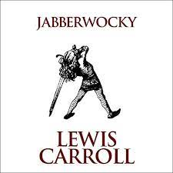
Maths | Number – Place Value  Number – Addition and Subtraction  Statistics | Number - Multiplication and Division  Measurement – Perimeter and Area |  | Number – Multiplication and Division  Number - Fractions |  | Number – Fractions  Number – Decimals and Percentages |  | Number – Decimals  Geometry – Property of Shapes | Geometry – Position and Direction  Measurement – Conversion of Units  Measurement - Volume
Science | Forces | Properties and changes of materials |  | All Living Things (habitats link to North America) |  |  |  | Earth and Space | All Living Things (Lifecycle’s link to SRE)
History | Britain’s settlement by Anglo-Saxons and Scots  The Viking and Anglo-Saxon struggle for the Kingdom of England to the time of Edward  the Confessor |  |  | Significant figure: Annie Edison Taylor |  |  |  | Non-European study – comparisons with Anglo-Saxon Britain | Local History study  (Warrington and Culcheth)
Geography | Name and locate counties and cities of the United Kingdom  Using maps, atlases, globes & digital/computer mapping to locate countries where the invaders came from. |  |  | Settlement, land use, economic activity  Environmental regions of North America  Countries of N. America  Latitude and Longitude  Regional focus on N. America  ‘Niagara Falls’ |  |  |  | Locating the Maya region and important landmarks in Mexico. | Region of UK (North-West), Economic activity
Computing | Coding |  | Online Safety | Databases | Game Creator |  |  | Concept Maps | Word Processing- Microsoft Word
Art | Grendel pencil portraits  Dragon eyes sculpture and acrylic painting (linked to Beowulf) |  |  | Artist study: Georgia O’ Keefe flowers (linked to North America and Science) | Textiles – Weaving (Navajo Blankets) |  |  | Mayan string printing and painting | LS Lowry inked to industrialisation.  (Research on Lady Lever Gallery)
DT | Viking Longboats |  |  | Cooking and Nutrition linked to Fairtrade Coffee morning |  |  |  | Mayan temples
PE | Set4U: Real Gym  Swimming |  | Set4U: Read Dance  Real PE- Unit 2 | Set4U: Real Gym  Cricket | Set4U: Invasion Games  Real PE-4  Athletics |  |  | Set4U: Real Gym  Real PE Pok-A-Tok | Set4U: Athletics  Team Games
RE  Where can people find guidance on how to live their lives? | Sikh Dharma  Why do people follow sacred books? |  | Christianity (God)  Why is it sometimes difficult to do the right thing? | Islam  Should religious teachings affect our laws today? | Christianity (Jesus)  What do we mean by a miracle? |  |  | Hindu Dharma  What might Hindus learn from stories about Krishna? | Christianity  How do people decide what to believe?
PSHE  Jigsaw | Being Me in My World |  | Celebrating Differences | Dreams And Goals | Healthy Me |  |  | Relationships | Changing Me
MFL | Revision of greetings, colours, numbers, the calendar and My Family  Description of Beowulf for ‘WANTED’ poster |  | Anglo-Saxon  Clothing Items | Going Places  Visiting Niagara Falls | Space  Describing planets, simple positions |  |  | Weather  Linked to Themed Work  Travelling to Chichen Itza | Where I live  Places in a town/city, famous landmarks

