# 

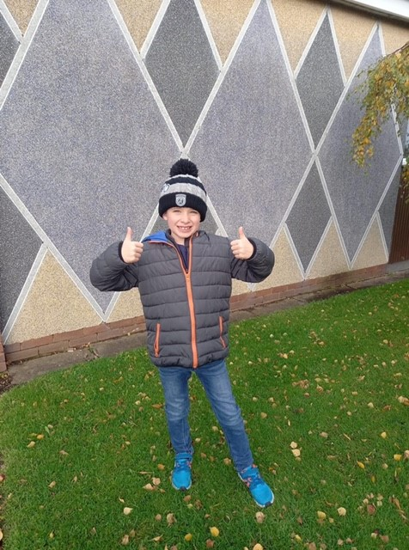

Huge thanks to Gill Smith and Peter Mills for their input in creating the scavenger hunt! We have had some fantastic feedback on this community event and have raised £310 so far! It is still running until the end of November and is a great way of getting in your family exercise! Information on signing up can be found here: https://www.justgiving.com/fundraising/twissgreen

# Scavenger Hunt

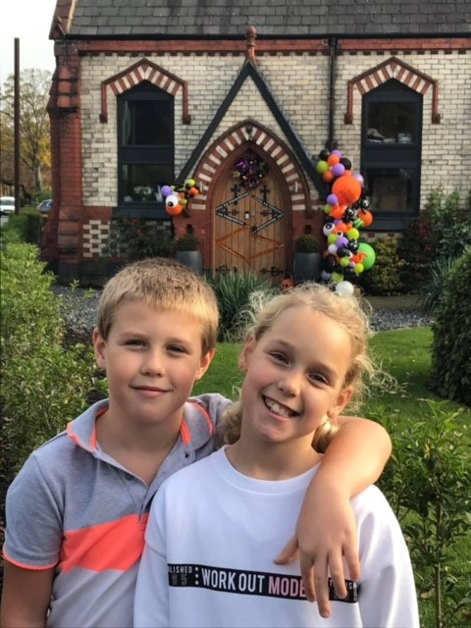

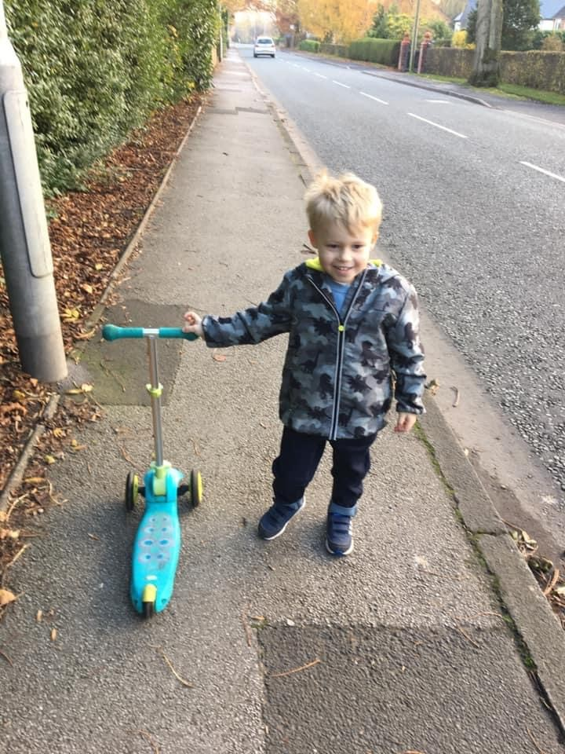

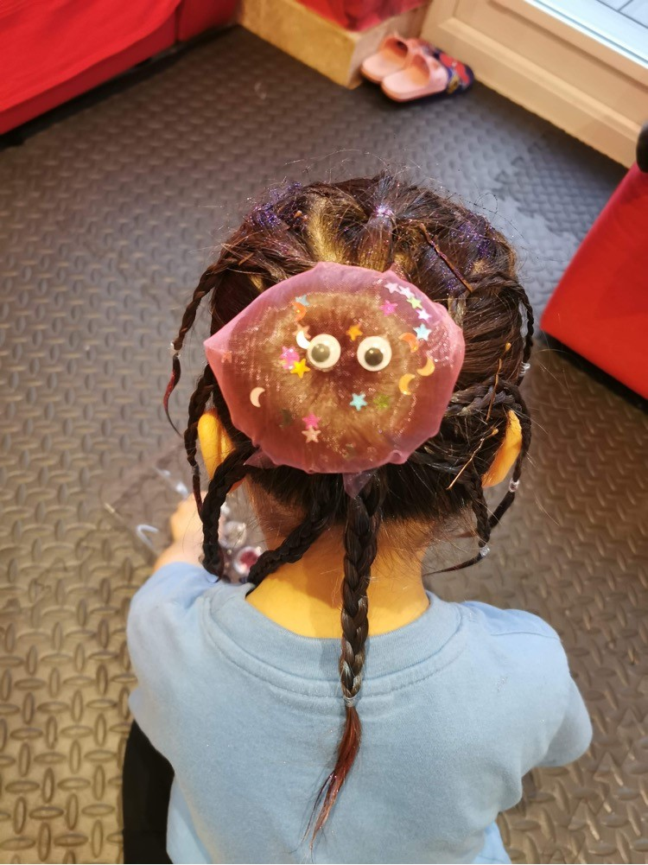

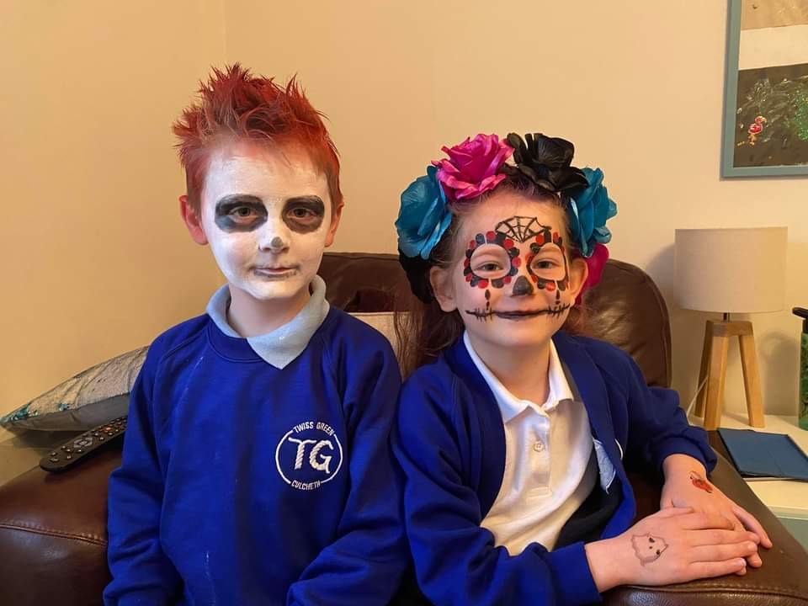

# Crazy Hair and Scary Face Day!

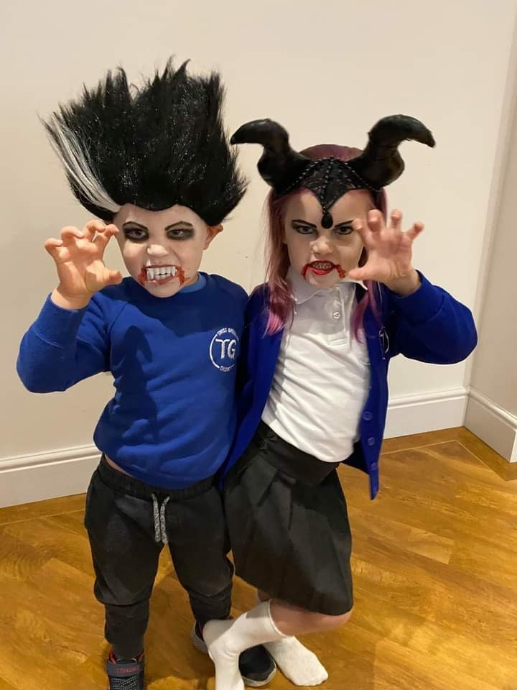

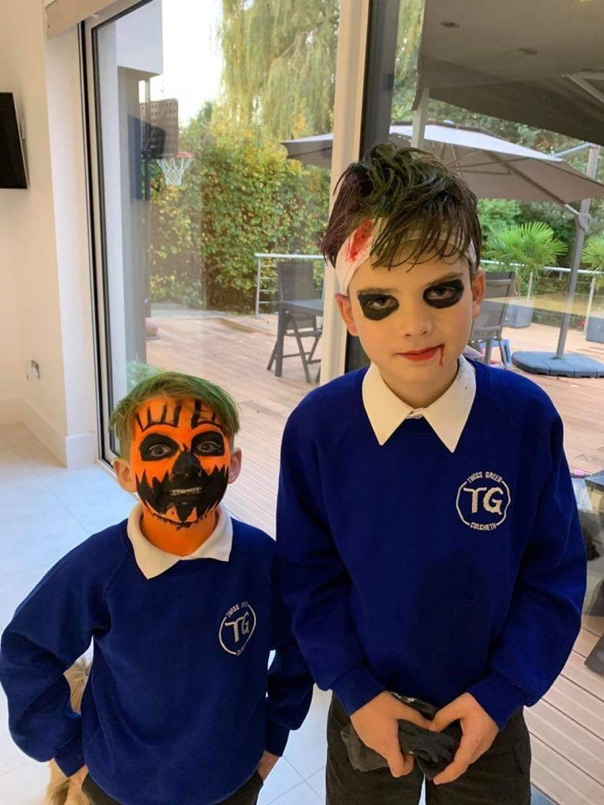

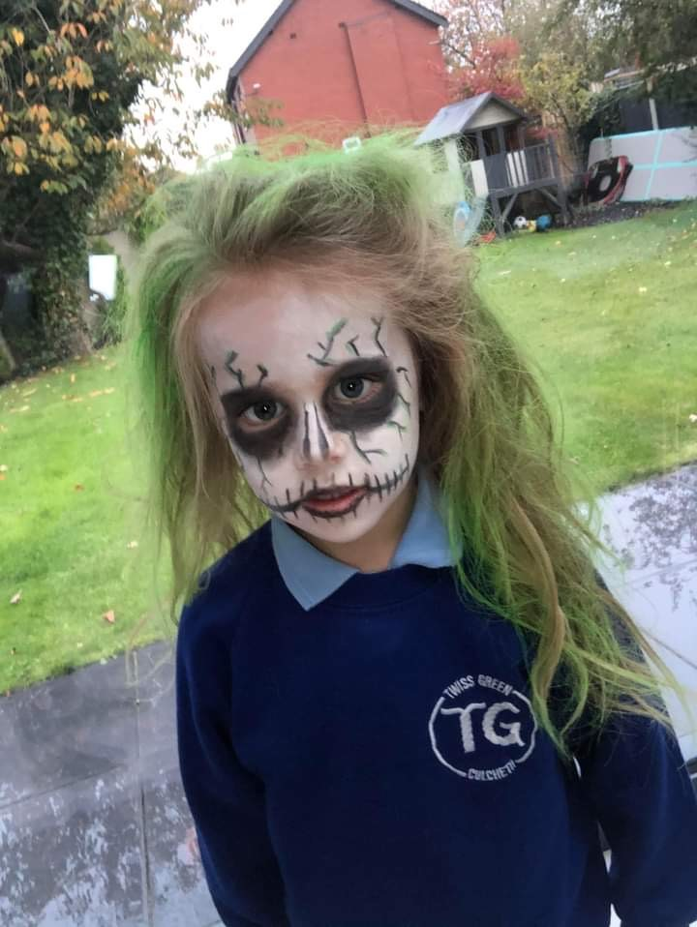

Massive thank you to Miss McGann and the teaching staff for allowing the children to attend school with their crazy hair and scary faces!!! We raised £127 and the children thoroughly enjoyed a bit of fun on their last day of term 😊

Since September and due to the effects of Covid, the PTFA have been unable to run many of our regular, successful, events such as pre-loved uniform sales, sweet jars, cake sales, movie nights and our community firework display. This has had a huge impact on our much-needed fundraising for the school, and not to forget the disappointment for the children who love to participate in these much-loved events!

At our most recent PTFA meeting, we came up with a few events for the remainder of the term which we hope the children will enjoy and our families will support us with. Please send us a friend request on Facebook for important updates! Twiss Green PTFA.

Exciting Updates and Information for the Term Ahead!

Twiss Green Primary

School

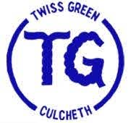

PTFA Newsletter!

# Fundraising Update

banner with apples and crayons

## Big PTFA Raffle

Special recognition is due the following students: **Theia Kerr- Year 2.**

Well done Theia on completing a 5k sponsored run to raise money for the hospital that cared for your grandad! You raised over £1000, what a fantastic achievement!

Please email us so we can celebrate any other pupil achievements!



# TG Sweaters

#### Thank You Students!

# Online Shopping

## Jingle Jangle Jog

Thank you to all that have ordered TG sweaters to wear on PE days. Your orders have raised over £110 so far. We’ve even had some teacher orders!! Please email [twissgreenptfa1@gmail.com](mailto:twissgreenptfa1@gmail.com) for more information or to place an order.



When doing shopping online over the festive period, there are ways in which you can support Twiss Green!

* Remember to use [#easyfundraising](https://www.facebook.com/hashtag/easyfundraising?__eep__=6&__cft__%5b0%5d=AZWktGJi3ZNL0wGQEYbZKDcfuUVXHFuAV9hcHUNjiXeiBRuES67oq3uxWAGjDz3mkM_waDRWEIrEF1_C5ZAv-U9Yv6_sB8ubqilsFUlg-VwsG7pvl2jMs5VB2oSuYV9t0b8&__tn__=*NK-R)! Over 4,300 shops and sites will donate, so you can raise for Twiss Green Parents' Association - Warrington when you buy gadgets, electricals, games consoles, toys, clothes, gifts or anything else! They are also offering - £5 donation for new supporter registrations 👍
* Did you know that if you shop at Amazon Smile, Amazon will donate 0.5% of the price of eligible purchases to Twiss Green PTFA?



TWISS GREEN PTFA NEWSLETTER

On Thursday 17th December, be will be hosting a sponsored ‘Jingle Jangle Jog’. Children will be asked to come school in their festive pyjamas/onesies and complete a jog around the school grounds in their year group bubbles! All children will receive a medal and treat in reward for their participation!! Please encourage family and friends to sponsor your child using the following link: https://www.justgiving.com/campaign/jinglejanglejog

As we will be unable to host our annual Christmas Fair, we have signed up to the Big PTFA Raffle! For every ticket you purchase, you will have 12 chances to win upto £5000*, and 50% of every ticket sold will go to our PTFA! Please visit-https://www/bigptaraffle.co.uk/support/twiss-green-c-p-school-wa3

# Tree Decoration

# In December, children will be invited to purchase

# a bauble/ornament for £1. They will be asked to

# decorate this and it will be displayed on the

# school tree. A prize will be awarded for the best

# decorated!