INTRODUCTION

by

The Headteacher, Miss L A McGann

Welcome to Twiss Green School! I hope that your association with us will be a long and happy one. The children and adults who work here feel that it is a very special place. We have tried to encapsulate in words what it is that makes it so special.

TWISS GREEN

‘a learning community where everyone matters and everyone cares’

We aim:

- to actively promote the development of children’s physical, personal, social and moral development through a broad and balanced curriculum as well as through their academic progress

- to create a safe and stimulating environment where everyone feels valued

- to enjoy learning and celebrate achievement, encouraging the children to take pride in themselves and all that they do

- to actively promote family values, self-esteem and awareness of the needs of others

- to equip the children with skills and confidence for their future lives and provide them with the opportunity to fulfil their potential

The school has twice been judged to be ‘outstanding’ by OFSTED; in April 2007 and again in November 2009. At the end of the last inspection the inspectors said, “This is an outstanding school… particularly successful in maintaining the consistently high standards that pupils reach in English, mathematics and science. These high standards reflect the outstanding progress made by all pupils. Outstanding teaching and a rich curriculum are important factors in helping pupils to achieve so highly. Pupils’ excellent behaviour, their willingness to learn and their excellent attendance are other key factors contributing to their outstanding achievement... Pupils display very good personal qualities, including their spiritual, social, moral and cultural development. This reflects the outstanding care, guidance and support provided...Pupils’ responses to questionnaires and in discussion showed that the vast majority feel very safe and greatly enjoy school”.

Under the current Ofsted inspection framework ‘outstanding schools’ are exempt from routine inspection; however, Ofsted retains the power to inspect if performance drops or other concerns are raised. The fact that we have not been inspected for so long means that we have maintained our Outstanding status for over eleven years.

If you wish to look around the school and have not already done so, I am very happy for you to call in or telephone at any time to arrange an appointment with me. If you are the parent of a child who will be starting in Reception in September then you will have the opportunity to attend one of three open afternoons or one evening meeting in the autumn term the year before your child is due to start school. I will also be happy to answer any further questions you may have after reading this prospectus.

School Teaching Staff
The teaching staff at Twiss Green are organised into two teams each of which is led by an Assistant Headteacher (AHT). Mrs Fuller (Year 2 teacher and AHT) leads the EYFS/Key Stage 1 team. The first year in school (Reception) is part of the Early Years Foundation Stage (EYFS). Key Stage 1 teachers are responsible for children from five to seven years of age (Year 1 and Year 2). Mr Wood (Year 6 teacher and AHT) leads the Key Stage 2 team. Teachers in Key Stage 2 are responsible for children from seven to eleven years of age (Years 3, 4, 5 and 6). The school is managed by its Senior Management Team (SMT) which has five members: Miss McGann, Mrs Fuller, Mr Wood, Mrs Puckey and Mrs Sinclair.

Each teacher coordinates a curriculum area (or in some cases works as part of a team in coordinating a number of curriculum areas) throughout the school. We have one class teacher who co-ordinates the provision for children with Special Educational Needs (SEN) throughout the school. We also have three teachers and one Higher Level Teaching Assistants (HLTAs) who provide cover for others when they are working on planning, preparation and assessment (PPA) or attending training courses.

Class | Name | Responsibilities
Reception  (Foundation Stage) | Mrs A Durr  Miss J Dunn | Physical Education  Newly Qualified Teacher in YR on Tuesday
Year 1(Key Stage 1) | Mrs S Puckey | History and Geography
 | Miss J Dunn | Newly Qualified Teacher in Year 1 on Thursday
Year 2(Key Stage 1) | Mrs K Fuller | AHT - Head of EYFS/Key Stage 1  English and Assessment
 | Miss J Dunn | Newly Qualified Teacher in Year 2 on Friday
Year 3(Key Stage 2) | Mrs L Nickson | Design & Technology, Art & Design, (with Mrs Milward)
Year 4(Key Stage 2) | Mrs L Milward | Design & Technology, Art & Design, (with Mrs Nickson)
 | Mrs S Sinclair | Mathematics
Year 5 (Key Stage 2) | Mr D Wood | AHT - Head of Key Stage 2, More Able, Information Technology and Computing and Science
Year 6 (Key Stage 2) | Mrs L Kelly | Personal, Social, Health and Economic Education, Religious Education
 | Miss K Roberts | Graduate trainee teacher (in Year 5 and Year 6 Monday to Friday)

Music Miss McGann coordinates music throughout the school; she teaches it to Year 5 and 6; she also runs the orchestra, the choir and a recorder club for Year 4 and Year 5.

Mrs Fuller teaches music in Year 2 and runs a recorder club for Year 3.
Miss Dunn teaches music in Year 1.

MFL (Spanish) Ms Browne coordinates Spanish and teaches it in Years 3 and 4. She also teaches Music in Years 3and Year 4.

SEN Mrs S Puckey

School Support Staff
The school staff does not simply consist of its teaching staff; there are many others who are important in the effective running of the school.

Learning Support Assistants
Miss J Nunnerley She supports one of our children in Year 1
Mr S Johnson He supports one of our children in Year 4
Mrs E Maw She supports one of our children in Year 4

Teaching Assistants
Mrs A Sanderson Works full-time with our Reception class, under the direction of the Reception class teachers Mrs Durr and Miss Dunn

Mrs E Maw Works part-time with our children in Year 3 and Year 4

Mrs P Harrop Works in Year 1 and Year 2, mainly in support of English and Mathematics.

Mrs K Dawber Works with children in Year 3 and Year 4, mainly in support of English and Mathematics.

Mrs P Nightingale Works with children in Year 5 and Year 6 mainly in support of English and Mathematics.

Mrs T Cotton Works with children in Year 1 and Year 2.

Miss S Taylor Works with children in Year 5 and Year 6 mainly in support of English and Mathematics.

Higher Level Teaching Assistants
Mrs C Evans Works closely with the SENCo, Mrs Puckey; she administers tests and deals with SEN administration matters.
Miss J Dunn Works with children in Reception, Year 1 and Year 2. She provides teaching staff with the opportunity to work with specific groups of children in an activity called Focused Group Work. This means that she teaches lessons that have been planned by the class teacher to large groups of children whilst identified groups of children are taught by the class teacher.
Caretaking
The school employs a part-time caretaker. Mr David Leeming is responsible for basic maintenance and keeping the building clean. He is assisted by a part-time cleaner, Mrs Jacqueline Leeming.
School Meals Staff
We have a school cook and two kitchen assistants (Mrs Helen Moors, Mrs Susan Foster and
Mrs Linda Haigh), who together prepare between 140 and 160 meals each day, plus mid-morning snacks.

Office Staff
The Office Manager is Mrs Catherine Henthorn; she is supported by two part-time clerical assistants: Mrs Karen Dawber and Mrs Vicky Watson. Our Finance Clerk, who works two days each week, is Mrs Christine Finch.

Midday Assistants
There are seven midday assistants on duty who take care of the children at lunchtime under the supervision of the Headteacher. They are: Mrs Dawber, Mrs Greenaway, Mrs Harrop, Mrs Maw, Mrs Nightingale, Mrs Redford and Mrs Worthington.

The School Governors
School governors are appointed for a four-year term of office, and by a variety of sponsoring bodies. They can be contacted, when necessary, through the school office. The role of the Governing Body is to decide the aims and policies of the school, its budget and staffing. It monitors the teaching of the National Curriculum in the school, and assists the Headteacher in all matters related to the school and its organisation. The Headteacher and the Governing Body work in a close and balanced partnership. At Twiss Green the Chair of Governors is Mrs Annick Platt and the governing body currently consists of the following members:

Mrs A Buchanan Co-opted Governor
Mr D Houghton Co-opted Governor
Mrs Annick Platt Co-opted Governor
Dr D McAreavey Co-opted Governor
Miss L A McGann Headteacher
Mrs S Puckey Teacher Governor
Mr D Lorton Co-opted Governor
Mr Mathew Porter Co-opted Governor
Mrs Vicky Nixon Parent Governor

Members of the Governing Body also serve on a number of committees. There are three main committees that meet on a termly basis, monitor specific areas of activity and report back to the full governing body when deemed appropriate. These committees are as follows:

Health and Safety
Performance and Curriculum (dealing with curriculum and staffing issues)
Resource Management (dealing with buildings and finance issues)

In addition, some of our governors are linked with specific classes. They visit their classes on a regular basis, attend special ‘Sunshine Assemblies’ and partake in educational visits. This, we feel, enables them to have a much more ‘hands on’ approach and gives them a flavour of the everyday life of the school.
The School Curriculum
As in all schools we are keen to ensure that the children receive a thorough grounding in English and Mathematics; teachers use the National Curriculum to plan for daily lessons to the children each day. However, it is our aim to ensure that they receive a broad, balanced and stimulating curriculum.
IT and C (Information Technology and Computing) is integrated into almost every aspect of a curriculum that includes the following areas: Geography, History, Design and Technology, Art and Design, Physical Education, Personal, Social, Health and Economic Education (PSHEE), Science, Music and Spanish. We follow a skills based curriculum which means that the children are taught a wide range of skills through a particular theme. For example in Year 5 the children learn about The Industrialisation of Manchester and Liverpool applying skills acquired in Geography, History, Art and Design, Music and IT and C. We also follow the Warrington Syllabus for Religious Education.

In our Reception class we employ a great variety of structured play activities designed to develop personal and social skills, to enhance early literacy and numeracy and to contribute to the children's knowledge, understanding and skills in other areas. Together these experiences lay firm foundations for Key Stage 1 of the National Curriculum.

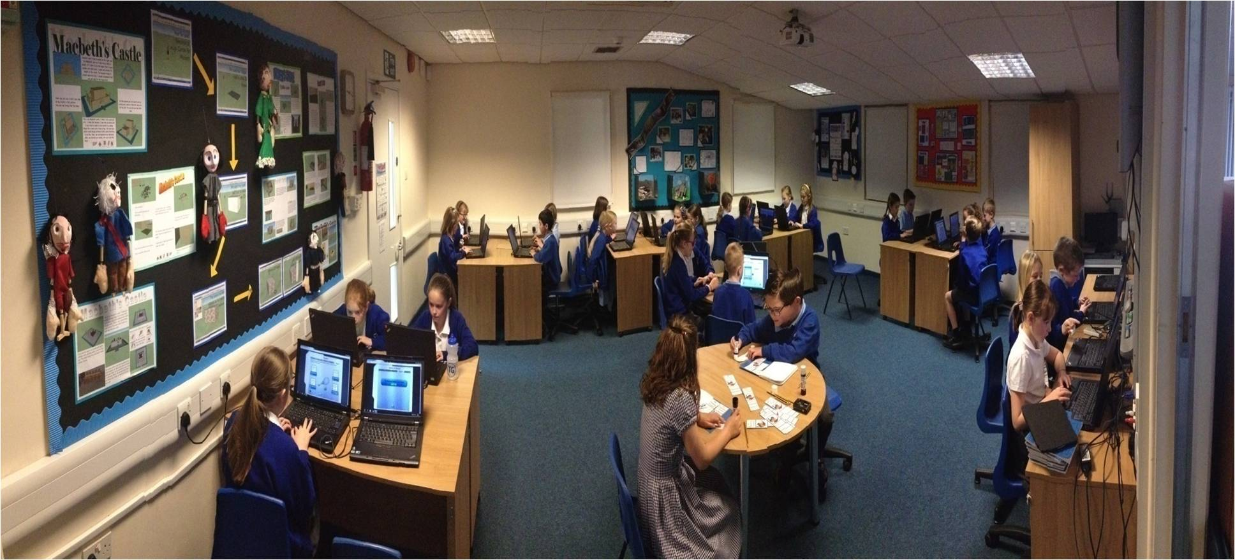

The children are organised into mixed ability classes of a single age-group. Children are taught principally by their own class teacher (or teachers, in those classes where we have a job-share arrangement, i.e. Year 1, Year 2 and Year 4). We aim to keep class sizes to a maximum of thirty children, although there is some variation from one class to another.

Within each class the children are taught using a range of teaching and learning strategies. We encourage the children to be involved in evaluating their own learning – they are actively encouraged to identify their own areas of strength and similarly areas for development. They are involved, with their parents and class teachers, in setting and achieving targets in mathematics and English. Children are encouraged to work collaboratively and independently –
we think that it is important that the children are given the opportunity to shape their own ideas.

During the early years of schooling, in Reception and at Key Stage 1, teaching methods are very much a mixture of practical activities and small-group working, with whole-class teaching also included. The children are encouraged to work in groups and individually at the appropriate level of difficulty; they are provided with opportunities throughout a lesson to review and summarize what has been taught and to assess their own progress against clearly defined learning criteria.
As the children progress through the school into Key Stage 2 they are encouraged to work collaboratively and independently, depending upon the task focus. We seek to offer a curriculum which caters for the needs of our children very much as individuals, and not simply as members of a larger group. It is also our aim to offer equal learning opportunities for all children, irrespective of sex, race, physical ability or creed.

Religious Education
There is a whole-school act of worship each day. This is led by the Headteacher, one of the two Assistant Headteachers or a member of the Senior Management Team; it normally includes a distinct time for worship and reflection. Modern and traditional hymns are a regular feature of these assemblies, which are mainly Christian in content. If parents want their child to be excluded from the daily act of worship and/or religious education lessons they should, in the first instance, contact the Headteacher.

‘Primary educational legislation requires that all maintained schools provide a balanced and broadly based curriculum that promotes the spiritual, moral, cultural, mental and physical development of pupils at the school and of society and prepare pupils at the school for the opportunities, responsibilities and experiences of adult life.’ Lancashire Agreed Syllabus 2016
At the centre of RE at Twiss Green Primary School is the question, “What is it to be human?” Through an enquiry based RE curriculum we aim to enable the children to develop the skills they need to rationally address this and many of the other big questions they will face throughout their lives.
It is not our intention to lead children to any specific faith but to use RE to encourage our pupils to learn and develop the positive attitudes of curiosity, wonder and appreciation, commitment, fairness and self-awareness to the beliefs and values of others.
The teaching of RE is approached in much the same way as the other humanities subjects. This means that each half term the children spend a whole week where there is a focus on a religious theme and it is used to develop their skills in a number of areas. All teaching is underpinned by Bloom’s hierarchy of skills which include: recalling information, explaining ideas, applying and analysing information, justifying a viewpoint and evaluating concepts and ideas.
Special Educational Needs
Mrs Puckey is our SENCo (Special Educational Needs Coordinator) and she is assisted in this work by Mrs Evans (former SENCo, but now our SEN Administrator). We identify a need at the earliest point and then make effective provision to improve the long term outcomes for the child. Our aims are as follows:

To regularly assess the progress of all pupils, thus identifying pupils making less than expected progress given their age and individual circumstances.

To identify pupils with special educational needs and disabilities and ensure that their needs are met through early intervention.

To ensure that all pupils have equal access to a broad, balanced curriculum which is differentiated to meet individual needs and abilities.
The aims of education for pupils with difficulties and disabilities are the same as for all pupils. Good special needs practice is good practice for all pupils.

It is the responsibility of all teachers to identify and meet the SEN of pupils across all curriculum areas and all aspects of teaching and learning.

To acknowledge and draw on parent knowledge and expertise in relation to their child and to involve parents in the planning of their child’s SEN provision.

To encourage pupils to express their views and fully involve them in decisions which affect their education.

To promote effective partnership and involve outside agencies when appropriate.

Sex and Relationships Education at Twiss Green School
Sex and Relationships Education is part of the curriculum at Twiss Green School. It is taught as part of science and PSHEE lessons by class teachers in Key Stage 1 and Key Stage 2 using the Christopher Winter scheme of work. We make arrangements for the School Nurse and our teaching staff to give lessons on menstruation to our Year 6 girls and on personal hygiene to the Year 6 boys. This is done in small groups, and parents are informed prior to these lessons taking place so that they may withdraw their child from this instruction, if they wish to do so.

Health Education is taught as part of Science and Personal, Social, Health and Economic Education (PSHEE); it is taught to all children throughout the school.

Sport at Twiss Green School
At Twiss Green all the children follow the real PE programme. It is fully aligned to the National Curriculum and Ofsted requirements and focuses on the development of agility, balance and coordination, healthy competition and cooperative learning. Sports such as tennis, football, cricket and hockey are taught as part of the Physical Education curriculum at Twiss Green and they play a significant part in the children's physical, social and personal development. In Key Stage 1 the children are taught to master basic movements including running, throwing and catching - these skills are applied in a range of activities. They participate in team games and perform dances using simple movement patterns. At Key Stage 2 the children develop a broader range of skills which enables them to follow a more extended programme of games, dance, gymnastics, athletics and outdoor activities.

We employ a professional coach who teaches the children a wide range of skills including rugby, cricket, athletics and short tennis. He also provides children in Key Stage 1 with a weekly after-school multi-skills club.

Children in Key Stage 2 (usually in Year 4) will have the opportunity to take a course of swimming and water safety lessons at the Orford Hub in the summer term.

Children in Year 6 also have the opportunity to participate in an outdoor and adventurous activities residential visit in the summer term. Further opportunities are offered to children in Years 4, 5 and 6 through after-school clubs (run by the staff) in other sports such as netball, running, football and rugby.

Admissions Procedures to the Reception Class
Parents/carers are invited to apply on-line for their child’s reception place for September 2019. If parents/carers do not have an email account or access to a PC, the school will provide support with this. Please contact Mrs Henthorn, Office Manager, on 01925 762346.

Parents should note that it is the Local Authority that is the Admissions Authority, not the Headteacher or the school's governing body. There is a single annual admission date. Children are admitted to school at the beginning of the school year during which their fifth birthday will occur. The school year runs from 1st September of any one year to 31st August of the following year. In other words, children are admitted in the September following their fourth birthday.

Deferred Entry to the Reception Class
You have the right to defer your child’s entry to school until he or she is of compulsory school age. Twiss Green Community School can guarantee a deferred entry to the Reception Class, provided that the place is taken up no later than the start of the Spring term. Please contact the Headteacher if you seriously wish to consider this course of action.

Timetable for Reception Class Admissions
The exact timetable for receipt of applications will vary slightly each year. The timetable for September 2019 admissions is:

1st September 2018: online application will be available at www.warrington.gov.uk/admissions

15th January 2019: deadline for online application

16th April 2019: offer letters will be sent to all Warrington applicants. An email will also be sent to those applicants who have requested to be informed by email.

If you would like any help or advice regarding admissions, please contact:

The Admissions Team,
Children and Young Peoples’ Services,
New Town House
Buttermarket Street,
Warrington. WA1 2NJ

Telephone: 01925 442902

Induction Arrangements for Reception Class Children
An induction course will take place during the period after Easter to the summer holiday prior to your child's initial admission. This will consist of an evening meeting designed to help you prepare your child for full-time schooling as well as a tour of the school, a chance to meet your child's teacher and to ask any questions you may have. There will also be an opportunity for your child to spend two afternoons in school during either the June or July prior to their admission in September. During the first week of the September term the children will attend on a half-day basis only. This is to ease them gently into school life.

Pupils Entering School at Other Than Reception Age
Pupils in any year group other than Reception who would like to be admitted to the school will be admitted by the Local Authority according to the same criteria as used for Reception children, up to the school's limit per year-group. This is 30 per class in each Key Stage.

Parental Choice of School
Parents can express a preference for their child to attend Twiss Green, even if they do not live close to the school. If the year-group is not full, their child will be admitted.

Catchment Area and Admissions Criteria of the School
Schools do not have a catchment zone from within which any child must be admitted to a school. Admissions priorities are as follows:

- Children in care and children formerly in care.
- Siblings, if the older brother or sister already attending the school is expected to continue at the school in the following year.
- Pupils for whom advice from a medical practitioner or psychologist has been provided by the parents in support of admission to a particular school which, in the Local Authority’s view, justifies admission to the preferred school.
- Pupils living nearest to the school defined ‘as the crow flies’ from the front door of the child’s permanent place of residence to the main entrance of the school.

Admissions Appeals
Parents have a statutory right of appeal against the decision of the admissions Authority. Details of the procedure are available from the Admissions Team (details on page 8).

Assessment and Reporting Arrangements
We report on your child's progress in every term of the school year. Parents' Evenings are held in the autumn and spring terms, at which you will typically have a ten-minute interview with your child's teacher to discuss their work and progress. In the summer term you will be sent a two page written report covering all National Curriculum subjects, the class teacher's and the Headteacher's general comments; we will also send you details regarding your child’s attendance. There is also space available on the report form for your own and your child's considered responses. One copy of this report is held in school and the other is for you to keep. Your child's teacher, or the Headteacher if necessary, is also available to discuss more urgent matters as they arise. If your child is receiving extra support or you would like to meet with the class teacher to discuss any issues regarding your child’s learning then each class teacher is available between 2.45pm and 3.10pm every Thursday afternoon.

In Reception class, assessment is an ongoing process carried out throughout the year. This culminates in an end of year report on progress in the Early Learning Goals. Assessment continues on a regular basis throughout the rest of Key Stage 1.

At the end of Year 1 the children undertake a phonics test; the result of this will be shared with you in the annual report at the end of July.

When the children are in Year 2 they undertake the Key Stage 1 Standard Assessment Tests, or SATs. These are designed to assess your child's attainments in mathematics and English. The results of the SATs will be reported to you in writing along with the annual report.
Assessment continues on a termly basis throughout Key Stage 2 and the children’s progress at the end of each year will be reported to you in the end of year annual report. In addition, the children in Year 3 undertake tests designed by the National Foundation for Educational Research (NFER) in mathematics, reading and non-verbal reasoning. These results are shared with parents at the end of the spring term.
Finally, towards the end of their last year at Twiss Green, children take the Key Stage 2 SATs, some of which are marked externally. Once again these are in the two core subjects of mathematics and English and you will be fully informed of the results. The school and national results are available on the internet and on the school website as well. SATs reporting arrangements will be more fully explained to you as the tests occur.
We track your child's progress throughout their time with us by regular marking of their class work and with regular testing and assessment. We encourage them to be involved in a target-setting process, so that they are committed on a personal level to improving their learning. These targets are discussed with parents at the two Parents’ Evenings in the autumn and spring terms.

Twiss Green Parent, Teacher and Friends’ Association
The school has a very active Parent, Teacher and Friends’ Association (PTFA). New parents automatically become members as soon as their child enters school. Supporting the activities of the PTFA is a particularly enjoyable way of supporting the education of your children and it is strongly recommended that you take an active part, however small, in the social and fund-raising activities it promotes.

The main objective of the Association is to work in partnership with the school in helping to advance the education of the pupils. In reality this means supporting and organising events and donating the proceeds to the school in the form of new equipment, or improvement projects. The PTFA can usually hope to raise in excess of £10,000 a year which it has, in the past, donated to the purchase of sports kit, science equipment, computers, play equipment, landscaping improvements, books and iPads. The Parent, Teacher and Friends’ Association elects a committee each year; in addition the Association is supported in its work by a small group of trustees.

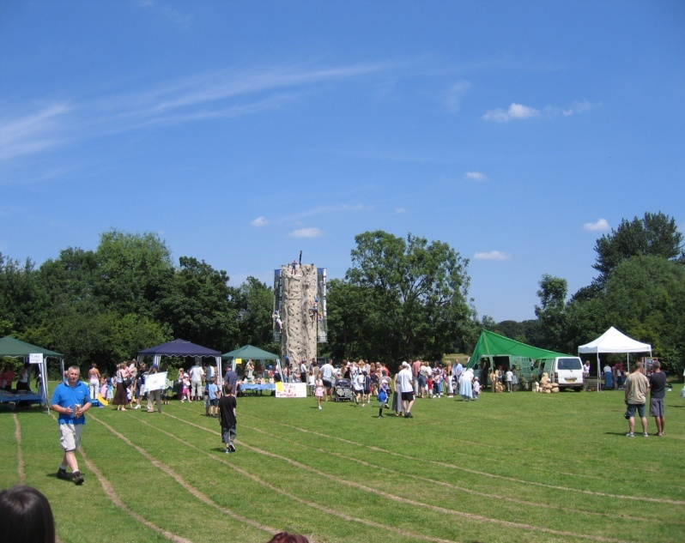
Everyone is welcome to attend PTFA meetings which usually take place in school; there are around six meetings during the year. Regular annual events include a fantastic Firework Display complete with a wide range of stalls and fairground rides, the Christmas and Summer Fairs, children’s discos in the autumn and spring terms, a leavers’ disco for the Year 6 children and a Christmas dinner dance which is usually held at Leigh Golf Club.

Details of PTFA activities are regularly updated on their own section of the school’s website: www.twissgreen.net

School Uniform
Members of the PTFA also administer the purchase and distribution of the school uniform. At the moment this is being organised by Mrs Vicky Watson who can be contacted on: 07989 659703. She deals with this non profit-making matter on the school's behalf. We do encourage the children to wear uniform - the predominant colour is royal blue. Uniform bearing the school's logo can be ordered through Mrs Watson.

All items of clothing for school should be clearly marked with your child's name prior to use.

- round-necked or V-necked royal blue sweatshirt
- royal blue cardigan
- white or sky blue polo shirt
- black shoes
- blue zip-up fleece (for winter wear)
- grey skirt
- grey trousers
- plain white blouse
- plain white shirt
Optional summer wear: grey shorts and blue striped or gingham dresses. Please note that we ask parents not to send their children to school in football or running shorts. Trainers and boots are not considered to be appropriate school-wear. We would like to ask for your co-operation in ensuring that children attend school wearing ‘proper’ shoes or sandals in summer, in either dark blue, black or brown.

We encourage the children to wear a sky blue T-shirt with the school logo and black shorts for PE lessons. These should be brought to school to change into for PE lessons, together with a pair of pumps which are used for some PE sessions in the hall. Children should wear trainers for outdoor games and these can be brought to school when needed (in the winter the children should also have tracksuit bottoms and tops in school). A small, named, drawstring PE bag in which to store these items will also be required.

Please note that while uniform cannot be compulsory before the age of eleven, we nevertheless hope and expect that parents will cooperate in sending their children to Twiss Green in uniform or very similar wear. Designer clothing or casual sportswear does not, we believe, engender the right attitudes towards school, and we prefer it not to be worn. Pre-loved uniform is available at a very reasonable cost; Mrs Watson also coordinates this for us.

Members of the choir and orchestra wear white shirts for special occasions such as concerts, along with school ties which have been provided by the PTFA.

As a precaution in terms of health and safety, children are not allowed to wear jewellery for school. Watches and stud earrings are the only exception to this rule.

The school does not permit children to have extreme haircuts that could serve as a distraction to other children and are not in keeping with the ethos of the school. This includes patterns shaved into the hair, excessive use of hair products and false hair. The definition of an extreme hairstyle is at the discretion of the Headteacher.
First Aid
We always have at least six properly qualified First Aid people on our school staff. (Training is provided by the Health and Safety Executive). Children in Year 6 also receive basic First Aid training. If your child receives a head injury during the course of the day you will be informed in person, by text and in writing.

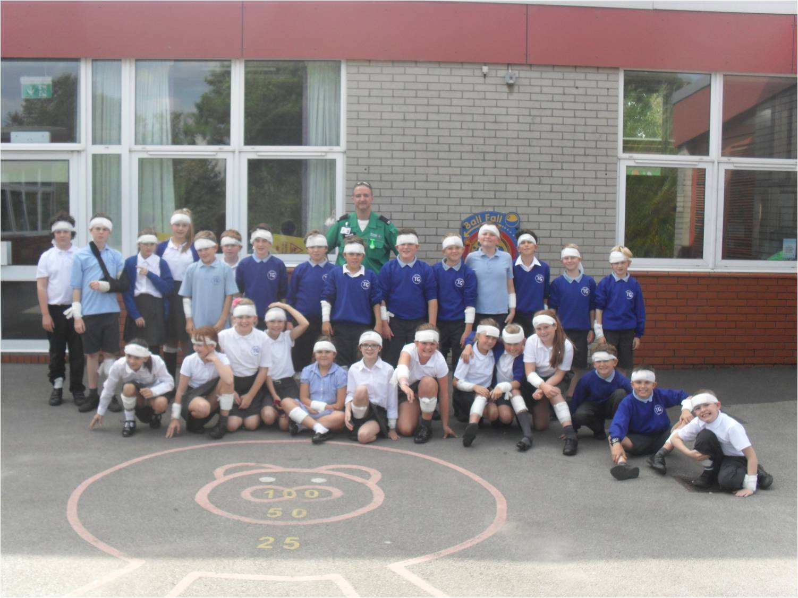

The School Charging Policy
Schools are not permitted to make compulsory charges for activities which take place mainly during the school day. Activities such as trips to places of educational interest can, however, cost very considerable sums of money. It is therefore necessary to ask parents for voluntary contributions in order to enable such visits to take place. Although there is absolutely no obligation to contribute in this way, a visit could not take place unless parents were willing to help. Wherever possible the school will endeavour to fund trips for children whose parents are experiencing financial problems. Children in receipt of Pupil Premium funding will not be asked to make a voluntary contribution towards the cost of school trips as outlined above.

Homework
At the beginning of each year you will receive information from your child's new class teacher on the subject of homework for that school year. In addition you will receive a letter at the beginning of each half term outlining the topics that will be covered in English, mathematics and Themed Work. It may well be that there will be suggestions for activities, visits, websites, books etc. that can be used by parents to enhance their children’s interest and learning.

The policy on homework at Twiss Green is one that has the support of parents, teachers and governors of the school. We use homework as an opportunity for the children to undertake further work closely related to their current class work, and to the National Curriculum Programmes of Study to which class work relates. Homework is sometimes used to complete work begun in class. The proper implementation of this policy will require parental co-operation if it is to be successful. Teachers may set and mark homework, but we need parents to oversee its completion on time. Teachers are under no obligation to mark homework that is handed in late.

Complaints Procedure
If parents are unhappy about any aspect of the life of the school there is a complaints procedure that should be followed. The procedure has three stages: a complaint will be heard, to begin with, by the member of staff involved, then by the Headteacher (either in person, or if you prefer, by phone) and finally by the Governing Body’s Complaints Appeal Panel. We have time limits in our complaints procedure to make sure that complaints are dealt with as quickly as possible.

If your concern involves the Headteacher then you should put your complaint to the Chair of Governors. The School Complaints Policy itself can be obtained from the office manager Mrs Catherine Henthorn and it can be downloaded from the school’s website.

Extra-Curricular Activities
A number of after-school club activities are organised for the children by the teaching staff. Learning the recorder is an option in Year 3; however the other clubs are only available to children in Years 4, 5 and 6. The activities do vary from time to time but we currently offer the following:

Football Recorders Film Club
Running Choir Art
Orchestra Netball Handicraft

These are run in seven-week blocks in the autumn and spring terms, although the choir, the orchestra, netball, football and running clubs continue in the summer term. At times, outside agencies will use the school premises to offer the children extra-curricular activities. In the past, activities on offer have included drama, fencing, archery and judo.

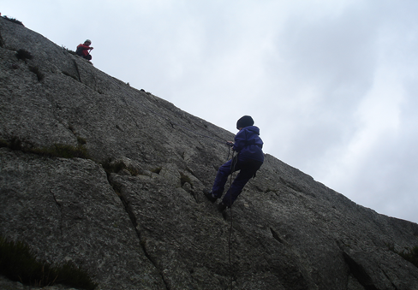
Every year we organise an outdoor and adventurous activity holiday for the children in Year 6. The children will undertake activities such as kayaking, abseiling, climbing, orienteering etc. which enable them to work with others, to meet challenges and to develop social and interactive skills under the supervision of trained instructors.
We have a school orchestra that practises each Thursday, and that performs at the school’s Summer and Christmas Fairs and also at the annual summer concert. It currently comprises ten musicians playing a wide variety of instruments including cornet, flute and violin.

There is also a large and active school choir which has over thirty members. It regularly performs on special school occasions: Harvest Thanksgiving, Christmas plays and an annual summer concert in the school hall. The children also perform in the wider community and have appeared at the MEN arena, the Parr Hall in Warrington and cathedrals in Liverpool and Manchester.
Breakfast Club

We run a Breakfast Club in school which operates from 7:45am until 8:55am. It is organised by Miss Becky Taylor, Mrs Carrie Anderson, Miss Jess Nunnerley, Mrs Gill Garner and Mrs Louise Worthington. It costs £4.50 per day and further information is available from the school office.

After-School Club
This operates between 3:15pm and 5:45pm and primarily caters for children in Reception class and children in Key Stage 1. It costs £8.50 per day when parents sign up on a termly basis. It is organised by Ms Sandra Taylor and she is assisted by Mrs Andrea Shaw, Miss Becky Taylor, Mrs Carrie Anderson and Mrs Gill Garner. Parents of children in all year groups can use the club on an ad hoc basis at a cost of £9.00 per full session.

There are local organisations willing to help parents who have problems collecting their children immediately after school. Please contact Warrington Children’s Information Service helpline on 443131 or log on to www.warrington.gov.uk/childcare

Holiday club
This was introduced during the Easter break in 2019 and has proved to be very popular. It is run by our Breakfast and After School club staff and is available during school holidays.

Punctuality
Parents are asked to ensure that children arrive in good time to start their lessons in the morning. If children are persistently late for school, their parents will be asked to discuss with the Headteacher how the situation can best be resolved, in the best interests of the child’s education.

Reporting of Absences
Parents are asked to inform the school office by phone or in person before 9:30am if their child is going to be absent. If at all possible they should give an indication as to how long the absence will last. On returning to school a written explanation should be brought in. If parents have not informed the school about their child’s absence by 9:45am they will be contacted by a member of staff from the school office. Please note that we refer to the Public Health England publication for information about illnesses called ‘Guidance on infection control in schools and other childcare settings’ and is available on the school website in the parents section. It is worth
noting that children who are suffering from diarrhoea or vomiting should be kept at home for 48 hours after the last episode.

Medical and Other Appointments
Parents are requested at all times to try to arrange medical and other appointments outside of the school day; however we do appreciate that this is not always possible in the case of hospital clinics. In those cases, parents should inform the school as soon as possible in writing: email to the school office is the preferred option ( twissgreen_primary@warrington.gov.uk ) so that school registers can be correctly recorded.

Family Holidays
The staff and governors firmly believe that family holidays should be taken during school holidays, since the prolonged withdrawal of a child for a holiday can have a significantly effect on a child's education. We undertook a detailed study of the impact that attendance had on attainment in 2015-16. At Twiss Green children in the top 20% for attendance had the following levels of attainment (the goal for all our children is to be at *Age Related Expectation):

28% exceeding *ARE 61% at *ARE 11% below *ARE

Those children in the bottom 20% for attendance had the following levels of attainment:

8% exceeding *ARE 58% at *ARE 33% below *ARE

In any case, an absence for family holidays would normally be classified as unauthorised and recorded on your child's records as such. If absence during term-time is unavoidable, then you should inform the Headteacher in writing, preferably 2 weeks before the absence date. Normal school hours are as follows:

Key Stage One children: 9.00 am - 12 noon
1.00 pm - 3.15 pm

Key Stage Two children: 8.50 am - 12 noon
1.00 pm - 3.20 pm

On the last day of each term, school finishes at 2.30 pm for all children.

Pupil Absence Rates
The school has a very good attendance record and we aim each year for an overall attendance rate of 97% (this equates to 5 days absence per child each academic year). Our absence rate last year was 2.5%. Unauthorised absence was 0.7%.

Security and Safety

As part of its Traffic Management System, the school has a car park for parents and visitors which is accessible from Petersfield Gardens, with a pedestrian gate for access to the school grounds. We ask that parents do not enter the staff car park when visiting school for any reason. In the interests of safety, the children are instructed not to walk across the staff car park at any time and we respectfully request that parents and other adults also refrain from doing so, in order to model safe behaviour.

The school doors have been equipped with locks to enable them to be secured from the inside, once the children are safely indoors. Children who arrive late for school for any reason will need to come in through the main entrance. Parents and visitors will also be unable to access the building during school hours, other than via the main entrance. If you need to take your child out of school at any time during the school day e.g. for a doctor’s appointment, you should come to the main entrance of the school, inform a member of staff in the school office and complete the appropriate paperwork.

At the end of the day parents of children in Reception and Key Stage 1 line up in much the same way as the children do in the morning. The children are seated inside the classroom and handed over to their responsible adults once they have confirmed their identity. It is very important that parents and carers understand that once the child has left the classroom the parent/carer must be responsible for supervision at all times. It is also important that if someone different is picking up your child at the end of the day that this is clearly communicated to school in advance. We cannot give permission to anyone to take a child home without direct parental consent.

For parents with children in different year groups, we suggest that you collect the younger child first (eg Reception child then Year 2 child).

Once the children make the transition to Key Stage 2 we expect them to exhibit a greater level of independence. Children in Year 3 and Year 4 will be released from the door next to the Year 4 classroom at the end of the day where they will meet up with the person collecting them from school. If they are unable to see that person they should return inside the school building until the person collecting them arrives. They will be supervised by a member of staff until 3.30pm then they will be taken to After School Club to be supervised by the staff there and the office staff will contact the parents/carers to arrange a pick up.

Children in Year 5 and Year 6 are released through the door next to the Year 6 classroom in order to meet up with the person collecting them. We understand that some of our older children prefer to walk home with friends –information about picking up at the end of the day is collected by the school at the beginning of the school year.

Lunchtime Arrangements
All children in Reception and Key Stage 1 are entitled to a free school meal; however, children may go home for lunch or bring a packed lunch if preferred. Children in Key Stage 2 have the same lunchtime choices; however, they pay for school dinners. We use ParentPay which is an online payment service for schools and parents. Once you have decided to send your child to Twiss Green you should receive communication with account details from the school office. It is perfectly acceptable to change to or from school dinners during the term, but please be sure to give notice of any changes. The cost of school meals for 2018-19 is £2.30 per day. We also ask for your co-operation in not sending your child to school with drinks in glass bottles, or hot food in flasks which can be a safety risk.

Snacks
Children in Key Stage 1 receive a free piece of fruit (including carrots and cherry tomatoes) on a daily basis as part of a government initiative. Many children in Key Stage 2 choose to bring a small snack for the morning playtime as well. To encourage healthy eating habits we do ask that parents co-operate by ensuring that morning snacks comprise only of healthy foods such as fresh fruit and vegetables. The children are also able to buy food at break time which is cooked by the school’s kitchen staff. This needs to be ordered for the whole week and paid for using ParentPay. Items available include toast (brown bread) and milk; both of which cost 25p per day. All children are encouraged to bring water bottles to school on a daily basis (these should be filled with water only). We ask you to purchase a re-usable container for your child ensuring that it is clearly labelled with his/her name and class. Water bottles are available from school at a cost of £1 each (again, we ask you to purchase these using ParentPay).

Although we actively encourage the children to eat healthily we do have one small concession. After consulting with parents and children it was agreed that on Fridays the children are allowed to have a special treat such as a chocolate bar at break time. We ask you not to send sweets, cake etc into school on children’s birthdays as this is at odds with our healthy eating policy.

You may be entitled to free school meals for your child. For further information please contact Children and Young Peoples’ Services, Warrington Borough Council, on telephone number 442938.

Administration of Medicines
Parents need to be aware that teachers and support staff are permitted to administer prescribed medicines to children. Parents need to bring the medicine into school at the beginning of the school day and complete a form (available either from the school website or the school office). If your child suffers from sudden onset illnesses such as asthma or epilepsy you should confirm, in writing, if your child falls into this category. We ask parents to keep us regularly informed about children who are on regular medication such as inhalers and to ensure that the medication we have in school is up-to-date.
Mobile Telephones
Children are not allowed to bring mobile phones to school. However in exceptional circumstance your child may bring a phone to school with a letter of explanation. Your child will be expected to hand over the phone to the office staff at the beginning of the day and sign the ‘signing in’ sheet. The phone will be returned to the child at the end of the day.

Further information and up-to-date news about school can be found by visiting our website.www.twissgreen.net

Privacy Notice - Data Protection Act 1998
We (Twiss Green Community Primary School) are a data controller for the purposes of the Data Protection Act. We collect information from you and may receive information about you from your previous school and the Learning Records Service. We hold this personal data and use it to:

- Support your teaching and learning;
- Monitor and report on your progress;
- Provide appropriate pastoral care, and
- Assess how well your school is doing.

This information includes your contact details, national curriculum assessment results, attendance information and personal characteristics such as your ethnic group, any special educational needs and relevant medical information.

We will not give information about you to anyone outside the school without your consent unless the law and our rules allow us to. We are required by law to pass some information about you to the Local Authority and the Department for Education (DfE). If you want to see a copy of the information about you that we hold and/or share, please contact the Office Manager, Mrs Henthorn.

If you require more information about how the Local Authority (LA) and/or DfE store and use your information, then please go to the following websites:

www.warrington.gov.ukandhttp://www.education.gov.uk/schools/adminandfinance/schooladmin/ims/datamanagement/privacynotices/b00212337/datause

http://www.education.gov.uk/schools/adminandfinance/schooladmin/ims/datamanagement/privacynotices/b00212337/datause/sharingdata

If you are unable to access these websites we can send you a copy of this information. Please contact the LA or DfE as follows:

Warrington Borough Council  Assistant Chief Executive’s Directorate  CYP Performance  4th Floor Quattro  Buttermarket Street  Warrington  WA1 2QB | Website: www.warrington.gov.uk  Email: eddat@warrington.gov.uk  Telephone: 01925 442956
Public Communications Unit  Department for Education  Sanctuary Buildings  Great Smith Street  London  SW1P 3BT | Website: www.education.gov.uk  email: http://www.education.gov.uk/help/contactus  Telephone: 0370 000 2288

website: http://www.education.gov.uk
email: http://www.education.gov.uk/contactforms/contactus/other.cfm
tel: 0870 000 2288

School Term Dates 2018-19

 | Date of Closing | Date of Re-opening
Autumn term 2018 |  | Tuesday 4thSeptember 2018
Autumn half-term | Friday 19thOctober 2018 | Monday 29thOctober 2018
Christmas 2018/19 | Friday 21stDecember 2018 | Monday 7thJanuary 2019
Spring half term | Friday 15thFebruary 2019 | Monday 25thFebruary 2019
Spring term break* | Friday 5thApril 2019 | Tuesday 23rdApril 2019
May Day Holiday | Friday 3rd May 2019 | Tuesday 7th May 2019
Whitsuntide | Friday 24thMay 2019 | Wednesday 5thJune 2019
Summer 2019 | Friday 19thJuly 2019

INSET: Monday 3rd September 2018 Friday 4th January 2019
Monday 3rd June 2019 Tuesday 4th June 2019
Monday 22nd July

*Easter weekend Friday 19th April and Monday 22nd April falls within the Spring Term Break

School Term Dates 2019-20

 | Date of Closing | Date of Re-opening
Autumn term 2019 |  | Wednesday 4th September 2019
Autumn half-term | Friday 18th October 2019 | Monday 29thOctober 2019
Christmas 2019/20 | Thursday 19th December 2019 | Monday 6thJanuary 2020
Spring half term | Friday 14th February 2020 | Monday 24th February 2020
Spring term break | Thursday 9thApril 2020 | Tuesday 28th April 2020
May Day Holiday | Friday 1st May 2020 | Tuesday 5th May 2020
Whitsuntide | Friday 22nd May 2020 | Wednesday 3rd June 2020
Summer 2020 | Wednesday 22nd July 2020

INSET: Tuesday 3rd September 2019 Friday 3rd January 2020
Monday 27th April 2020
Monday 1st June 2020 Tuesday 2nd June 2020

Assessment
Children in Year 1 take a phonics test in June and results are reported nationally. Those who do not achieve the expected standard are expected to re-sit the test in Year 2.

Year 1/ Year 2 Phonics Results 2017
Year group | Number of children | Working at | Working towards | Disapplied
Y1 | 30 | 29 | 1 | -
Y2 | 1 | - | - | 1

Year 1/ Year 2 Phonics Results 2018
Year group | Number of children | Working at | Working towards | Disapplied
Y1 | 30 | 28 | 2 | 1
Y2 | - | - | - | -

A new National Curriculum was introduced by the Department for Education (DfE) in September 2014 and a new form of assessment introduced in the summer of 2016. Children’s level of attainment is assessed against four statements in Key Stage 1, these are:

HNM = has not met the expected standard
WTS =working towards the expected standard
EXS = working at the expected standard
GDS = working at greater depth within the expected standard

*NB Children who are unable to access the Key Stage 1 curriculum are assessed to be working below the standard of the pre-key stage (BLW) or at pre-key stage foundations (PKF) for the expected standard.

Key Stage 1 SATs Results 2017
 | *BLW | * PKF | HNM | WTS | EXS
Reading | - | 3% | - | 10% | 39%
Writing | 3% | - | - | 3% | 55%
Mathematics | - | 3% | - | 3% | 35%

Key Stage 1 SATs Results 2018
 | HNM | WTS | EXS
Reading | - | 23% | 77%
Writing | - | 11% | 89%
Mathematics | - | 11% | 89%

The DfE assesses children in Key Stage 2 using scaled scores in Reading, Maths and GPS. A scaled score of 100 represents the expected standard for each test. If a child achieves a scaled score of 100 or more it means they are working at or above the expected standard in the subject. If a child achieves a scaled score of less than 100 it means that they may need more support to reach the expected standard. The highest scaled score possible is 120, and the lowest is 80.

Writing is not marked externally but assessed by the class teacher and moderated internally and on occasion by an external moderator. Children are assessed as follows:

HNM = has not met the expected standard
EXS = working at the expected standard

Key Stage 2 SATs Results 2017
 | 95-99 | 100 + | 110 +
*GPS | 3% | 97% | 68%
Reading | 6% | 94% | 52%
Mathematics | 3% | 97% | 61%
*Grammar, punctuation and spelling

 | HNM | EXS
Writing | 6% | 94%

Percentage of children achieving 100 in reading, writing and  mathematics combined | 87%

Key Stage 2 SATs Results 2018
 | 95-99 | 100 + | 110 +
*GPS | 6% | 94% | 86%
Reading | - | 100% | 35.5%
Mathematics | 3% | 97% | 35.5%
*Grammar, punctuation and spelling

 | HNM | EXS
Writing | 6% | 94%

Percentage of children achieving 100 in reading, writing and  mathematics combined | 91%

Attendance is not collected for pupils under 5 at Early Years Settings or Maintained Schools as part of Censuses for the Department for Education. This footnote can be removed where Local Authorities collect attendance for under 5’s for their own specific purposes.
Local Authority to provide a link to their website with information on uses they make of data and any other organisations they share data with. Ideally they should also provide an address where parents without internet access can write for information.

