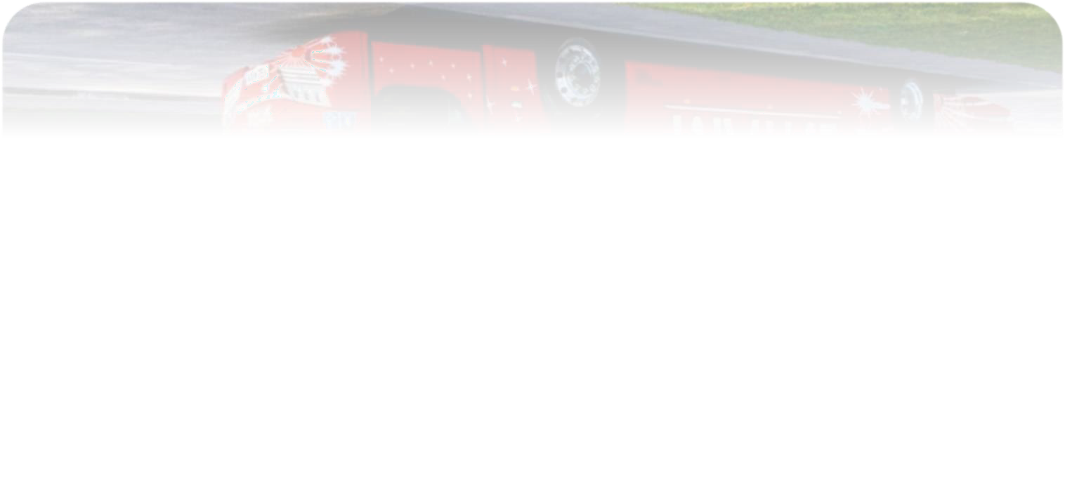
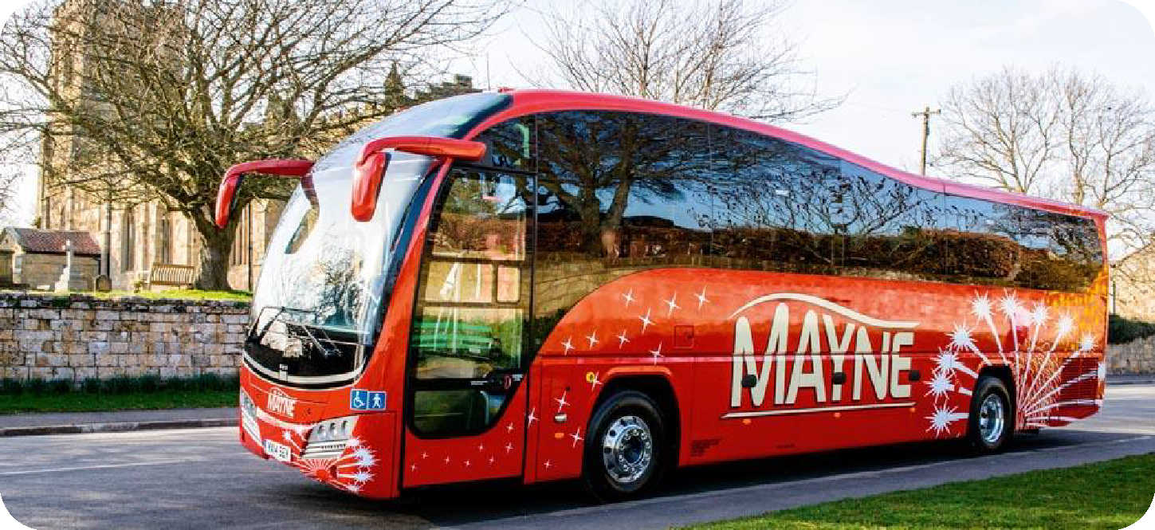
2020

COVID-19 – Driving Risk Assessment

e Lane Warrington
Marsh House Lane
Warrington
WA1 3QU

ACTIVITY: Delivery of SET routes under COVID 19 Conditions
Route: All contracted routes
ACTIVITY
HAZARDS
WHO MIGHT BE
HARMED AND HOW
CURRENT CONTROL MEASURES
POTENTIAL FOR
HARM AT PRESENT (RISK STATUS)
ADDITIONAL CONTROL MEASURES TO REVISED RISK
Driving a Bus or
Coach
Transmission of
COVID 19
Drivers of Vehicles
None prior to COVID 19
AB
REDUCE HARM
Drivers will maintain 2m at all times from service users. The area/seats immediately behind the drivers seat have been decomissioned. This should reduce the chance of transmission of the virus between the driver and service users and vice versa. See other control measures in Drivers Covid-19 risk assessment - separate document.
STATUS
WHO IMPLEMENTS
BE
OPERATOR/DRIVER
Driving a Bus or
Coach
Transmission of
COVID 19
Drivers of Vehicles
None prior to COVID 19
AB
Drivers have been advised to clean
their cab area prior to and after the route has been completed. See other control measures in Drivers Covid-19 risk assessment - separate document.
BE
OPERATOR/DRIVER

Social Distancing passengers | Transmission of COVID 19 | All passengers | None prior to COVID 19 | AB | The route currently operates coaches with seat capacity between 49 and 72 With varying students numbers required to travel we can maintain social distancing through identification of specific marked seats. Students will be invited to board one at a time and will be directed to the seat furthest away that is marked.  Once seated the next students will be invited to board. They will be instructed to disembark in the same way. As a guide for private hire trips we aim to carry 28 passengers on a 59 seat coach. with the new guidence in relation to school travel we will endeavor to ensure pupils are sat in bubbles and on priviate school runs although social distancing isnt required we will issue seat numbers to ensure passengers are kept in same household or year group bubblespassengers. Other control  measures: • Drivers advised to leave  their window open.  - maintain a 2 metres social  distancing rule while the passengers | BE | DRIVER / OPERTOR/ SCHOOL
- Passengers will be encouraged to
wear face coverings during the
journey. • Drivers informed to turn off any air conditioning systems on vehicles as a precaution. Air conditioning could spread Covid-19, as the units aren’t designed to filter out particles as small as the coronavirus.
Travelling on a coach | Transmission of Covid 19 | All Passengers | Non prior to COVID 19 | AB | All touch points cleaned after each trip | BE | Driver
 |  |  |  | AB | Hand sanitizer on the coach. | BE | Driver / Operator/ Passenger
 |  |  |  | AB | Frequently sanitizing the coach via use of a Fog-it machine - including Air conditioning systems | BE | Operator / Garage Department
 |  |  |  | AB | Passengers & Drivers to wear masks | BE | Operator / Driver / Passengers
 |  |  |  | AB | All Staff to be Temperature Checked Daily | BE | Operator

